**Gaining The**

**Competitive Edge**

Analyzing the Importance and Potential Success Drivers of Political Marketing Strategies Regarding the 2021 Federal Elections in Germany

Philipp Kläger

December 23rd 2021

Master Thesis Marketing Research

Master Program – M.Sc. Marketing Analytics

Marketing Department Tilburg School of Economics and Management

Tilburg University

Master Thesis Supervisors: dr. L.K. Deer Tilburg University

*First Reader*

dr. B. Deleersnyder Tilburg University

*Co-Reader*

**Management Summary**

Empirical evidence suggests that a substantial amount of voters is susceptible to persuasion: 23% of polled German voters were uncertain of their voting decision two weeks before the election, a similar share of 10 to 20% of undecided voters can also be found in other European countries like Italy and France (Spiegel 2021, Alam & Riva 2019, La Repubblica 2006, Mannheimer 2003). Hence, political marketing should be considered a suitable tool to gain voter support and gain a competitive edge against other parties – particularly in close elections.

In addition to the content stances, the measurements of sentiments, emotions, and text similarity can be used to validly determine party positioning (Silva & Proksch 2021, Burst et al. 2021, Jolly et al. 2019, Laver et al. 2002). Based on the work of Giavazzi et al. (2020), which identified a shift in text similarity between German political parties following terror attacks, this research conducted a topic-specific analysis to identify similar shifts in central election topics. The topic-specific stance analysis detected several shifts in language by the parties. The topic of Corona was discussed with more right-wing language by all parties compared to their overall stance position. In contrast, the topic Environment was discussed with more left-wing language by all parties compared to their overall stance position. For this purpose, this research collected two large data sets from Twitter and the 2017- and 2021-party programs of the six major political parties.

As a unique contribution to political marketing research, this paper conducted a comprehensive text analysis of the party activities on Twitter regarding the 2021 Federal Elections in Germany. Additionally, this research derived practical, data-driven recommendations for potential success drivers for political marketing regarding elections. These recommendations address the public candidate image, emotive strategies, and practical techniques to manipulate voter behavior. Firstly, as the Social Democrats (SPD) and Liberal Democrats (FDP) display, effective political marketing on Twitter is conductible with short texts and low lexical diversity, so the message is easily understandable. Secondly, the question of whether these messages should be in the majority positively or negatively connoted is primarily determined by the incumbent status of parties. Thirdly, the public image of the lead candidate seems to be one of the central drivers for voter behavior. Fourthly, situational contingency and epistemic value seem to be suitable tools to enhance the candidate image.

**Table of Contents**

**Chapter 1. Introduction 1**

**Chapter 2. Literature Review 3**

2.1 Delineation of Political Marketing 3

2.2 Impact of Political Marketing in Elections 5

2.3 Impact of User Generated Discussions in Elections 6

**Chapter 3. German Political System 7**

**Chapter 4. Conceptual Model 9**

4.1 Conceptual Framework 9

4.2 Measurements 10

4.3 Central Election Topics 12

4.4 Hypotheses 13

**Chapter 5. Data 14**

5.1 Data Collection and Transformation 14

5.1.1 Raw Data Collection 14

5.1.2 Data Cleaning 15

5.1.2 Data Preparation and Variable Operationalization 16

5.2 Data Overview and Model-Free Evidence 17

**Chapter 6. Methodology 19**

**Chapter 7. Results 22**

7.1 Sentiment & Emotion Analysis 22

7.2 General Stance Analysis 25

7.3 Topic-Specific Stance Analysis 28

**Chapter 8. Discussion 31**

8.1 Summary 31

8.2 Marketing Implications 32

8.3 Limitations and Future Research 35

**References**

**Appendices**

1. Data
2. Results
3. Model-Free Analysis
4. German Political System

**Chapter 1. Introduction**

On September 26th, 2021, voters in Germany elected a new federal government for the upcoming legislature period. As the first incumbent chancellor in German history, Angela Merkel (CDU/CSU) did not run for office again after 16 years as head of government. The campaigning for her successor was a tight and suspenseful race with substantial fluctuation in voter supports: three parties in the Conservatives (CDU/CSU), Greens (Grüne), and Social Democrats (SPD) all held supremacy in the polls at some point. On election day, the SPD only prevailed by 1.6% – a difference of only approximately 700,000 votes out of 61 million eligible voters (Politico 2021).

This paper argues that political marketing should be considered a capable tool to generate a competitive edge over opposing parties in tight campaign races like this one for several reasons. Firstly, political marketing can generate a competitive edge because most politicians utilize social media to amplify messages and a platform for public display (Silva & Proksch 2021). Particularly Twitter as a text-centric platform has gained popularity among German politicians: roughly 70% of the current parliament members utilize the platform to connect with the voting population and colleagues (Pollytix 2021). As the digital form of election posters and press releases, it has been argued that Twitter may soon replace its analog predecessors due to its cost-efficiency and more effective targeting (Tawadrous 2021, Jaursch 2021, Jaursch 2020).

Secondly, political marketing can generate a competitive edge because many voters are susceptible to persuasion. Two weeks before the elections, 23% of polled German voters were uncertain of their voting decision (Spiegel 2021). A similar pattern of 10 to 20% of undecided voters can also be empirically found in other European countries like Italy and France (Alam & Riva 2019, La Repubblica 2006, Mannheimer 2003). Lastly, political marketing can generate a competitive edge because it can persuade people in their voting decision. After becoming president in 2016, Donald Trump famously stated: “I think I would not be here if I did not have social media” (Wired 2016). His digital media director specified that Twitter was crucial for gaining votes, and Facebook was fundamentally important for fundraising (Fujiwara et al., 2020). Indeed, recent research substantiates evidence for the effect of Twitter and Facebook on the voter turnout in favor of candidates dependent on the party (Fujiwara et al. 2020, Liberini et al. 2018). Hence, this paper argues that social media's effect on the elections results from the perceptions of party positioning and the election-specific circumstances.

In addition to the content stances, the measurements of sentiments, emotions, and text similarity can be used to validly determine party positioning (Silva & Proksch 2021, Burst et al. 2021, Jolly et al. 2019, Laver et al. 2002). Based on the work of Giavazzi et al. (2020), which identified a shift in text similarity between German political parties following terror attacks, this research conducted a topic-specific analysis to identify similar shifts in central election topics. For this purpose, this research collected two large data sets from Twitter and the 2017- and 2021-party programs of the six major political parties. The first data set represents the posts of verified 2021 candidate accounts from the six major parties within the campaign period (Dec. 2020 – Sep. 2021). The second data set represents the posts from user-generated discussions based on election-relevant hashtag queries within the last four weeks before the elections. As initial positioning of parties, the 2019 Chapel Hill Expert Survey was deployed for the left-to-right positioning of the six major political parties and assigned to the texts of the respective 2017 party programs (Jolly et al. 2019).

In line with current research, the two incumbent government parties (CDU/CSU & SPD) have utilized more positive sentiment than the opposition parties (Crabtree et al. 2020). Furthermore, the sentimental and emotive strategy of the fringe parties displays the expected results: whereas the Left exhibits the highest scores for negative sentiment and the emotion sadness, the Alternative (AfD) showcases the lowest score for positive sentiment and the highest scores for the emotions anger, disgust, and fear in their political marketing activities. The text-similarity of the six major political parties has continuously and considerably increased between 2017 and 2021 party programs and campaign period tweets - thus resulting in the most similar relative positioning for all parties for the campaign period tweets. The topic-specific stance analysis detected several shifts in language by the parties. The topic of Corona was discussed with more right-wing language by all parties compared to their overall stance position. This shift was arguably led by the Liberal Democrats (FDP) and the Alternative (AfD) based on tweet volume. In contrast, the topic Environment was discussed with more left-wing language by all parties compared to their overall stance position. This shift was arguably led by the Greens based on tweet volume. As a unique contribution to political science, this research conducted a comprehensive text analysis of the party activities on Twitter regarding the 2021 Federal Elections in Germany. Additionally, this research derived practical, data-driven recommendations for potential success drivers for political marketing regarding elections. These recommendations include the public candidate image, emotive strategies, and practical techniques to manipulate voter behavior.

**Chapter 2. Literature Review**

This chapter will present the current state of scientific research regarding the object of study. In order to lay the proper foundation for this research, a delineation of political marketing (chapter 2.1), as well as the current empirical evidence regarding the impact of political marketing (chapter 2.2) and user-generated discussions (chapter 2.3) in elections are displayed in the following. Hence, this literature review serves as the academic framework for this research's conceptual framework and model.

**2.1 Delineation of Political Marketing**

**Political marketing** can be delineated as the usage of marketing concepts and practices in political campaigns by numerous individuals or organizations to appeal to their stakeholders. It is operationalized by influencing public opinion, promoting certain ideologies, winning elections, or passing legislation corresponding to the needs and wants of a selected group of people in a particular society (Hughes & Dann 2006, Newman 1999a, Newman & Perloff 2004). These stakeholders do not necessarily possess aligned interests, as political marketing includes tasks like communication with party members, potential sources of funding, media channels, and its arguable core in regards to elections: the electorate (Lock & Harris 1996). Building on the delineation of its characteristics, success in political marketing reflects the materialization or realization of the desired behavior of the focal groups. Subsequently, success explicitly includes shaping the public opinion, gaining new funding partners or winning votes in elections. Regarding the topic of this research, marketing for election campaigns, political marketing mainly targets voter behavior, as it is the measuring stick of success.

From an *academically-oriented perspective*, voter behavior can be construed in a model by Newman (1999c) that operates with two assumptions. Firstly, the model asserts that voter behavior results from a set of individual cognitive beliefs drawn from a vast variety of communicational and media sources (e.g., word-of-mouth marketing) and personal affiliations to particular groups or social environments. Secondly, the model assumes that voters are consumers of a service they receive from politicians. Axiomatically, the consumers choose the candidate with the highest perceived value. The model proposes five cognitive domains that affect this perceived value: political issues, social imagery, candidate personality, situational contingency, and epistemic value.

While political issues refer to the policies the candidate indicates to introduce once elected, **social imagery and candidate personality** reflect the usage of stereotypes to induce specific associations (e.g., with archetypes) to establish the desired image in the voter’s mind. **Situational contingency** utilizes the presentation of hypothetical events to illustrate why the opposing candidate is not fit for the office that he is in contention for (Newman 1999c, Newman & Perloff 2004). Situational contingency is relevant for the 2021 German Federal Elections because the lead candidate Armin Laschet (CDU), was confronted with situational contingency. His adversaries stressed the perceived danger of a pending government led by him in public events and social media. The hashtags #laschet-verhindern*(meaning: prevent Laschet) and*#laschetdarfnichtkanzlerwerden*(meaning: Laschet* must not become chancellor) are popularly used examples for this (Tagesspiegel 2021). **Epistemic value** is a concept that is supposed to induce curiosity in choosing a particular candidate. In election campaigns, smaller parties usually utilize epistemic value to compensate for the discrepancy in credibility compared to bigger parties resulting from the lower levels of awareness of and knowledge about smaller parties (Newman 1999c, Newman & Perloff 2004).

From a *practice-oriented perspective*, political marketing as a persuasion tool to influence voter behavior is nowadays based on data-driven insights drawn from recent polls and market research results. Stakeholder and SWOT analysis are deployed to effectively reach the identified target groups of potential voters (Magnecon 2021). According to political consultant Johannes Hilje, specializing in political marketing in Germany, there are five critical factors to the success of political marketing strategies (Hilje 2021):

1. The contents should be attractive, mobilizing, and platform-optimized.
2. Building a loyal supporter group (community building) is crucial in creating and preparing content.
3. The communication and content should be tailored to small, distinct target groups to improve their effectiveness (**microtargeting**).
4. Influencers associated with the party can facilitate a bigger stage and hence organically introduce the message to a larger audience.
5. Parties should react quickly to content interactions by users to spark ongoing, potentially viral conversations on the platforms.

In social media, the Alternative (AfD) is the frontrunner in terms of followers and subscribers on the platforms of Facebook and YouTube, whereas the Greens lead on Twitter and Instagram. Additionally, the Alternative (AfD) has the highest percentual user interaction regarding comments, likes, and shares on all mentioned platforms (Hilje 2021).

**2.2 Impact of Political Marketing in Elections**

10 to 20% of polled voters are uncertain about their voting decision until one week before the election date, suggesting the opportunity for a large scale of voters to be targeted successfully by political marketing efforts (Alam & Riva 2019, La Repubblica 2006, Mannheimer 2003). Activities are most likely to affect the voting decision when conducted in a personal manner like with direct messages on social media platforms (+4.1%), traditional door-to-door conversations (+2.5%), and volunteer phone calls (+1.9%) (Jacobsen 2015, Dale & Strauss 2009, Green et al. 2012, Bond et al. 2012). Political advertising has no significant effect on the overall turnout of voters in elections across all parties because the mobilizing and demobilizing effects of ads verge on neutralizing each other. However, it increases the probability for individual parties that more voters of the party’s respective target group decide to exercise their voting right, thereby shaping the partisan composition of the electorate in its favor (Spenkuch & Toniatti 2018).

Regarding the 2021 Federal Elections in Germany, there were several interesting peculiarities in the political advertising activities: all six political parties spent considerably more money on political advertising, as the respective budgets range from 6.5 to 20 million EUR. Even though its share is growing, the deployment of Google and Facebook is still comparatively small. In the last 90 days before the elections, the parties only spent up to 575,000 EUR on Google and Facebook ads, as the Left only spent 32,000 EUR. Except for the Greens, no party initiated a voluntary disclosure of their activities (Zandt 2021). Right-wing parties like the Alternative (AfD) regularly blurred the lines between negative campaigning and disinformation to discredit their political adversaries. This allegation includes the evidence-free narrative of systematic voter fraud and sexist, migrant, and racist disinformation (Jaursch 2021). The Liberal Democrats (FDP) currently face allegations for using ethically questionable microtargeting techniques on Facebook, like presenting mutually exclusive stances on climate changes depending on individual preferences (RND 2021). Partially acknowledged by Facebook, the Facebook Ad Library is missing thousands of ads by political parties, candidates, and ministries, as a recent research project displays (TargetLeaks 2021).

**2.3 Impact of User-Generated Discussions in Elections**

**User-Generated Discussions**can be defined as user-made content to initiate or participate in conversations on online platforms like social media (Techopedia 2021). Parties can exploit user-generated content to improve their party image, add authenticity, or humanize the candidate in the public eye (Chia 2017). User-Generated Discussions are particularly relevant to this research because they are indicators for the public perceptions of parties and candidates. Additionally, they arguably indirectly affect voter behavior, as the recent example of YouTuber Rezo and his viral video “The Destruction of the CDU” (19.3 million views) displays (Rezo 2021, Allgaier 2020). One week before the European Elections in 2019, the popular German YouTube creator Rezo (1.56 million subscribers) posted a controversially discussed video that gained nationwide attention. In this video, he accused the conservative government of climate inaction and openly invoked his followers to specifically not vote for the current government parties and the right-wing Alternative (AfD). Because of the expertise and credibility associated with social media creators like Rezo by their followers, it can be insinuated that incidences like this directly affect their followers' opinions and subsequently indirectly affect their voting behavior (Allgaier 2020).

The impact of user-generated discussions is also suitably illustrated by studies about the phenomenon labeled as “hate speech”. This term refers to aggressive or generally degrading statements towards people based on a group affiliation, usually issued on online platforms or social media. Measured by the number of accounts, a small group of accounts seems to be responsible for creating and disseminating the majority of hate speech posts on Facebook: an estimated 5% of the hate speech creating accounts generate over 50% of the likes for degrading comments. These accounts can be linked to the groups of supporters for the right-wing party Alternative for Germany (AfD) and the more radical Identitarian Movement (Identitäre Bewegung). This dissemination of hate speech is often coordinated in terms of content and timing (Kreißel et al. 2018). Both Geschke et al. (2019) and Kreißel et al. (2018) conclude that this coordination aims to place political content in the middle of society and create the impression that the communicated attitudes toward this content correspond with the attitudes of the average user. Subsequently, a distorted representation of opinion is obtained, which also affects the users' actual opinions (Geschke et al. 2019, Kreißel et al., 2018). Applying these research results to election campaigns could mean that hate speech on social media also affects voter behavior. The distorted representation of opinions could cause a change in party allegiances and voting choices.

**Chapter 3. German Political System**

Based on the 2017 federal election results and the weekly polls in 2021, six parties were projected to satisfy the necessary conditions of being included in the new parliament in July 2021, when the work for this research started (Bundestagswahl 2021b). Parties that represent minority populations are explicitly excluded from these regulations. In 2021, this rule solely applies to the Southern Schleswig Voters’ Association (SSW), representing the Danish minority in the state Schleswig-Holstein (SSW 2021). This projection was confirmed by the results of the 2021 federal elections (Politico 2021). Subsequently, these six parties will be referred to as the "major" parties in the following and introduced briefly, hierarchically ordered based on the second vote proportions earned in the 2021 federal elections (Bundeswahlleiter 2021d, Bundeswahlleiter 2021f). Besides these established players, a total of 47 other, smaller parties were also eligible for the federal elections in 2021, usually summarized as "Others" in polls and election results (Bundeswahlleiter 2021a). The party introductions are based on the dossiers of the impartial state institution German Federal Agency for Civic Education to exclude potential biases. A more comprehensive overview of these parties and an introduction to the German electoral system can be found in Appendix D.

**Social Democrats (SPD) – 25.7% (2021) / 20.5% (2017)**

Founded in 1863 as the Sozialdemokratische Partei Deutschlands, the Social Democrats (SPD) embody the oldest German party. Giving up its adherence to Marxism with the Godesberg Program in 1959, the SPD began to open up as a party of the people in the late 1950s, becoming the typical representation of its traditional clientele of industrial workers, as well as a large proportion of middle-class voters. Its program can be characterized by the values of freedom, justice, and solidarity (Decker 2021c, Krell & Woyke 2015).

**Christian Democrats (CDU/CSU) – 24.1% (2021) / 32.9% (2017)**

Founded in 1945 as the Christlich Demokratische Union Deutschlands, the Christian Democrats (CDU/CSU) represent a conservatively oriented party of the Christian-bourgeois camp in Germany. Typically associated with anti-socialist orientation, its program is characterized by conservative, liberal and Christian-social positions, the modernization of which repeatedly touches on core elements of the party's identity. As the only major twin party in Germany, the union consists of technically two different parties, as the CDU acts as its representative in 15 of 16 German states. At the same time, the CSU only exists in Bavaria instead of the CDU (Decker 2021c, Bösch 2018, Zolleis & Schmid 2013, Bösch 2002).

**The Greens (Die Grünen) – 14.8% (2021) / 8.9% (2017)**

Founded in 1993 as Bündnis 90 / Die Grünen, when the western Greens merged with the eastern Bündnis 90, the Greens were the most successful newly founded party in the history of the Federal Republic until the emergence of the Alternative (AfD). They were founded in protest against environmental destruction, the use of nuclear energy, and nuclear armament. Since the 1980s, they have established themselves permanently as the fourth force in the party system alongside the CDU/CSU, SPD, and FDP (Decker 2020c, Probst 2015, Probst 2013, Anan 2013).

**Liberal Democrats (FDP) – 11.5% (2021) / 10.7% (2017)**

Founded in 1948 as the Freie Demokratische Partei, the Liberal Democrats (FDP) were the only minor party formed at the beginning of the Federal Republic to permanently secure its parliamentary existence aside from the big parties of CDU/CSU and SPD. Occupying a pivotal role in forming coalitions, they have been the favorite partner in coalitions by both CDU/CSU and SPD. With their liberal economic positions and restrictive stance on refugee and European policy, they have an above-average reach among higher-income voters (Decker 2021a, Treibel 2018, Walter 2010).

**Alternative for Germany (AfD) – 10.3% (2021) / 12.6% (2017)**

Founded in 2013 as Alternative für Deutschland in response to measures to combat the European currency crisis, the Alternative has most notably fought for restrictive immigration policy, a conservative social policy, and an anti-establishment orientation. Now typically identified as a right-wing populist party, the Alternative has been successful in all elections since 2014. The Alternative became the first right-wing party in post-war Germany to earn representatives in each of the 16 state parliaments and the Bundestag (Decker 2020b, Lewandowsky 2018, Decker 2016).

**The Left (Die Linke) – 4.9% (2021) / 9.2% (2017)**

Founded in 2007 as *Die Linke*, the Left Party assembles the remnants of the East German Socialist Union Party (*SED*), previously organized in its immediate successor organizations Party of Democratic Socialism (*PDS*) and later also the Labor and Social Justice Party (*WASG*) since the German reunification in 1990. It thus has its roots both in the pro-labor-union environment and the protest against the social policies of the 2000s (Decker 2021b, Neu 2018, Pfahl-Traughber 2013).

**Chapter 4. Conceptual Model**

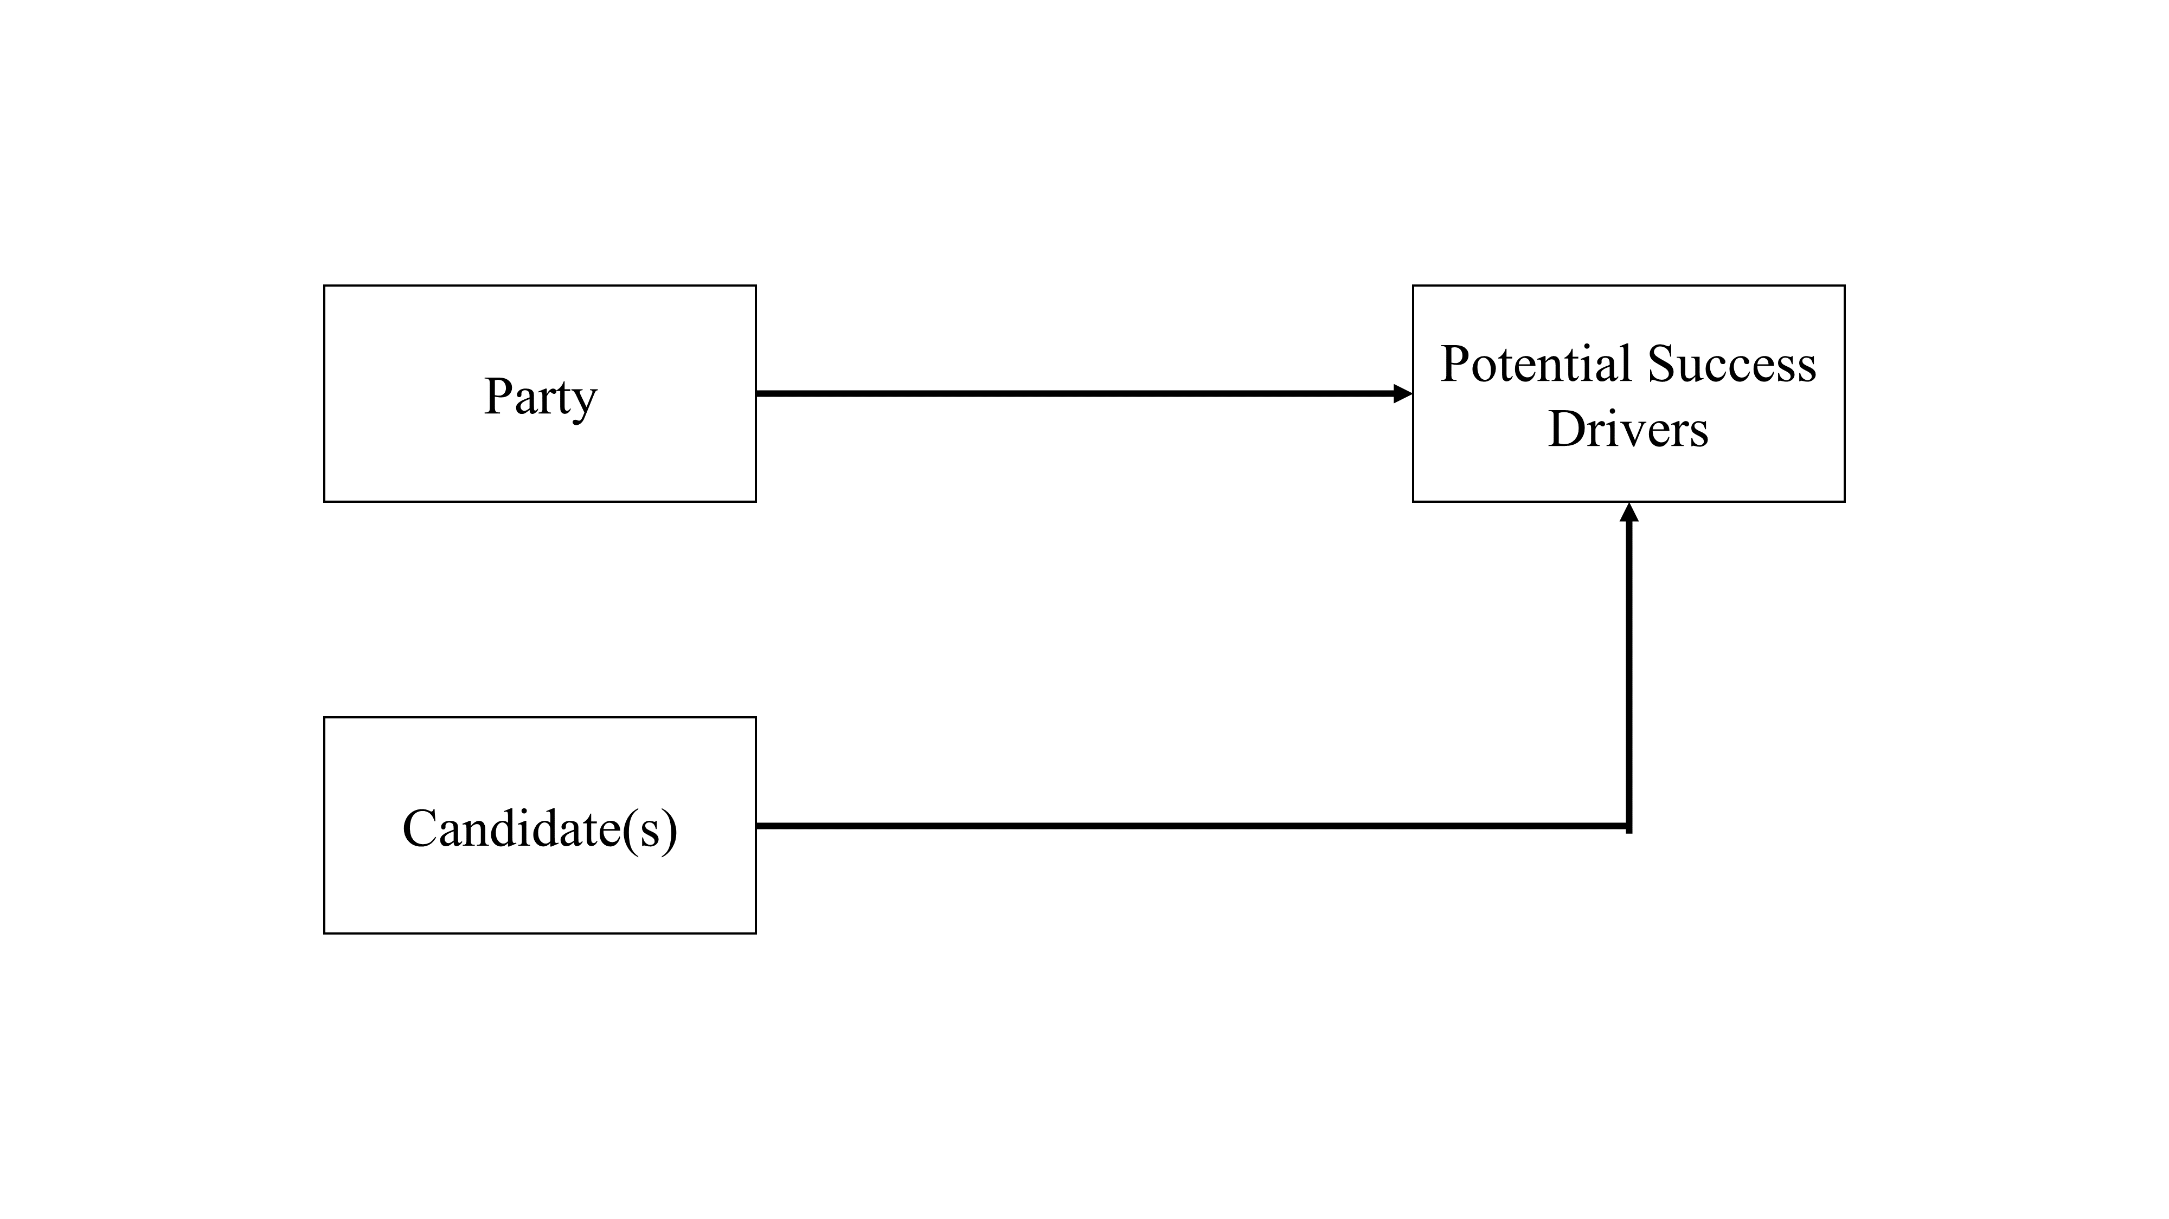

*Figure 1: Conceptual Model (own representation)*

As figure 1 displays, this research proposes that the success of political marketing regarding elections is dependent on the party and candidate peculiarities in potential success drivers. This proposition is examined by identifying differences among parties and candidates as distinct categorical entities through various text analysis methods. Firstly, the conceptual framework (chapter 4.1) delineates what precisely constitutes success for political marketing in this research. Secondly, the relevance and validity of the chosen measurements (chapter 4.2) to identify potential success drivers are demonstrated. The methodology explains the specific procedure for each measurement in detail (chapter 6). The choice of the central election topics for the topic-specific stance analysis is derived from journalistic election coverages (chapter 4.3). The specific hypotheses and expectations (chapter 4.4) are presented and reasoned.

**4.1 Conceptual Framework**

|  |  |  |  |  |  |  |
| --- | --- | --- | --- | --- | --- | --- |
| **Table 1**  *Data basis for the Conceptual Framework (own representation, source: Politico 2021)* | | | | | | |
| **Party** | **SPD** | **CDU/CSU** | **Greens** | **FDP** | **AfD** | **Left** |
| Election Result I  September 24th 2017 | 20.5% | 33.0% | 8.9% | 10.7% | 12.6% | 9.2% |
| Campaign Start Polls  December 8th 2020 | 16.0% | 36.0% | 19.0% | 6.0% | 9.0% | 7.0% |
| Election Result II  September 26th 2021 | 25.7% | 24.1% | 14.8% | 11.5% | 10.3% | 4.9% |
| Legislature Period Delta | +5.2% | -8.9% | +5.9% | +0.8% | -2.3% | -4.3% |
| Campaign Period Delta | +9.7% | -11.9% | -4.2% | +5.5% | +1.3% | -2.1% |
| Election Winners  New government | yes | no | yes | yes | no | no |

As previously established, success in political marketing is constituted when the activities lead to the wanted appeal to its stakeholders (Hughes & Dann 2006, Newman 1999a, Newman & Perloff 2004, Lock & Harris 1996). Measured in voter behavior, success in political marketing is constituted when votes are won compared to the last election (1) or compared to the campaign start (2). Additionally, it can be considered a success if the party takes part in the new government coalition (3) because it allows the party to implement beneficial policies for its stakeholders. Applying this to the current German political landscape, only the Social Democrats (SPD) and Liberal Democrats (FDP) managed to be successful in all three dimensions (see table 1). Hence, these two parties will serve as representatives of success in political marketing for the 2021 federal elections in this research.

There is no legal regulation in the German constitution that determines election campaigns' specific beginning or ending. The prevailing opinion is that the determination of the election date can be viewed as the starting point for the election campaigns of parties and candidates (Bundeswahlleiter 2020d). On December 8th, 2020, President Frank-Walter Steinmeier announced that the election would take place on September 26th, 2021 (Bundeswahlleiter 2020e). Hence, the campaign period is limited between December 8th, 2020, and September 26th, 2021.

**4.2 Measurements**

In addition to the content stances, the measurements of sentiments, emotions, and text similarity can be used to validly determine party positioning (Silva & Proksch 2021, Burst et al. 2021, Jolly et al. 2019, Laver et al. 2002). Based on the work of Giavazzi et al. (2020), which identified a shift in text similarity between German political parties following terror attacks, this research conducted a topic-specific analysis to identify similar shifts in central election topics. The following demonstrates the relevance and validity of sentiment and emotion analysis, stance analysis, and text similarity to identify potential success drivers.

**Sentiments and Emotions.** Sentiments and emotions characterize two of the focal points in the history of modern political science. From a static point of view, emotions tie-up behavior and attitudes towards political actors as the affective “glue” to assure reliance on longstanding complexions (Sears 1993). From a dynamic point of view, emotions as affective responses play a crucial role in subsuming judgments of political actors and current circumstances (Marcus 2000, Lodge & Taber 1998, Hastie & Park 1986). These capabilities have been used many times in political marketing strategies, subsequently creating research areas like “affective polarization”, particularly on social media platforms like Facebook and Twitter (Park et al. 2021). Hence, an emotive strategy expressed in sentiments and emotions can be viewed as potential success drivers in political marketing campaigns.

Sentiments and emotions can be measured with sentiment and emotion lexicons (Mohammad & Turney 2013, Jockers 2020). This research utilizes the Syuzhet, Afinn, Bing and NRC lexicons (see chapter 6 for more details).

**Stances.** Political stances refer to publicly stated opinions by parties and their representatives and thereby their relative contentwise positioning compared to other parties (Chou et al., 2021). In Germany, the general stances of parties are regularly expressed in party programs (also called manifestos) approaching state or federal elections, in which parties explain their opinions and define their positionings in regards to specific topics (DW 2021). These stances change relatively little over time, as most partisans display longstanding loyalty in party allegiances, and repositioning is perceived as costly due to the often-occurring alienation of their voters in the process (Chou et al., 2021). However, the emergence of new parties has raised the necessity for contentwise differentiation and the attractiveness for repositionings multiple times in German history, as the empirical evidence suggests regarding the Greens and the Left (Decker 2021b, Schumacher et al. 2013, Decker 2016, Decker 2013). The right-radical Alternative for Germany (AfD) has recently raised the question for the established parties whether and how to recapture voters with repositionings. In line with this, recent empirical evidence suggests that AfD voters can be persuaded when established parties accommodate their preferences (Chou et al., 2021). Hence, a stance strategy expressed in ideological positioning and text similarity can be viewed as potential success drivers in political marketing campaigns.

Stances can be measured based on expert evaluations of their ideological position and based on their text similarity to attain a relative positioning (Burst et al. 2021, Giavazzi et al. 2020, Jolly et al. 2019, Laver et al. 2002). Both approaches are utilized in this research (see chapter 6 for more details).

**4.3 Central Election Topics**

Three topics were selected for the topic-specific stance analysis. Each of them was chosen due to its arguably high relevance for the elections and the justifiable expectation of differences in stances across parties.

**Corona.**  This topic was selected because its regulations altered the living conditions throughout the entire campaign period. This omnipresence especially applies during the time of the second ”hard” lockdown with severe social distancing measures (Dec. 2020 – Apr. 2021) and later on in the discussion about the vaccination policies (Wiwo 2021b). Political actors often displayed different stances: e.g., portraying themselves as the defeaters of the pandemic or as defenders of constitutional freedoms and rights (Junginger 2021).

**Environment.** This topic was selected because the floods in July 2021 in western Germany and their aftermath caused a controversial societal debate about climate change in public discussions and political parties. The event caused 180 deaths and over 4.5 billion euros in damages (bpb 2021c). Fiercely debated on social media as one of the most controversial moments in the campaign period is the laughter of Conservative lead candidate Laschet (CDU) during a speech of German president Steinmeier expressing his condolences to the victims of the catastrophe at the site of the disaster (Lütz 2021, Handelsblatt 2021). The range of stances is extensive: the Greens declared climate change as the essential topic in their campaign, and the Alternative (AfD) barely acknowledges its existence and importance with their program stances (BBW 2021).

**Digitization.** This topic was selected because it is considered as one of the most pivotal challenges of the 21st century. With the Covid-19 pandemic as a catalyst, the accelerated digitization is omnipresent in society today: home office, hybrid working, digital university, virtual conferences and many more peculiarities have drastically gained importance during the last two years (Brings & Weber 2021). Political parties have repeatedly stressed the importance of the digitization, even though their stances differ considerably: the Social Democrats (SPD) guarantees the provision of fast Internet for everyone, and the Greens even want a legal entitlement. The Left wants broadband and mobile networks to be in public hands, while the Alternative (AfD) wants to promote regional structures more strongly in the expansion process (Tagesschau 2021). The topic is particularly interesting for young voters (Gensing & Reisin 2021).

**4.4 Hypotheses**

**Sentiments and Emotions**

*H1: The sentiments and emotions utilized in the tweets of official party and candidate accounts differ across parties.*

*H2. The scores for negative sentiment and emotions connoted in the tweets of official party and candidate accounts are highest for the political fringe parties (The Left & AfD).*

The rise in political polarization refers to a contemporary phenomenon that describes the development of increasingly unfavorable sentiment towards opposite political parties or ideologies. There is substantial empirical evidence that social media as a “filter bubble” or “echo chamber” has been a significant driver for this phenomenon. Social media makes it exceedingly simpler to connect with like-minded people, find confirmation for the own selective attention in a process that is often referred to as self-sorting or enclave extremism (Boxell 2017, Sunstein 2007). On the one hand, social media makes information considerably more accessible to voters. However, on the other hand, it also augments information asymmetries by amplifying the views and influence of minority and extremist voters (Matejka & Tabellini 2020). Whereas incumbent government parties use the most positive sentiment in their activities, the rhetoric of radical or populist parties elicits anxiety, anger, resentment, and nostalgia (Betz 2020, Crabtree et al. 2020, Salmela & von Scheve 2018). Firstly, this gives reason to expect that sentiments and emotions differ depending on the political party and candidate. Secondly, this gives reason to expect that the two fringe parties in the German political system (The Left & AfD) utilize negative sentiment and emotions the most in their political marketing activities.

**Stances**

*H3: For central election topics, the stances of parties change towards the stances of the parties that are the public opinion leader for the topic in the public discussion.*

Following exogenous events that are perceived as threats from other cultures (e.g., terror attacks), a shift in text-similarity on Twitter among German political parties can be substantiated. This shift is characterized by the assimilation of party language towards the right-wing party Alternative (AfD) by the other five major political parties (Giavazzi et al. 2020). This finding enables two critical inferences. Firstly, following a sudden, exogenous event that affects the entire society (e.g., terror attack), all parties seem to assimilate their positions and language towards the same relative positioning. Secondly, this assimilation arguably strengthens the party's public support that initially represented the eventual consensus.

Applying this to the 2021 German Federal Election campaigns could mean that there have been similar shifts in text-similarity of party language regarding relevant exogenous events this year. As the reasoning for the central election topics displays, the Covid-19 related lockdown at the beginning of 2021 and the floods in western Germany in July 2021 can be viewed as such relevant exogenous events. Subsequently, being an opinion leader for a central election topic could be a significant success driver in the political marketing for election campaigns (bpb 2021c).

**Chapter 5. Data**

In this chapter, a summarizing overview of the utilized data sets of this research shall be presented. To gain an easier understanding, the explanations for the raw data collection (chapter 5.1.1), data cleaning (chapter 5.1.2), as well as data preparation and variable operationalization (chapter 5.1.3), are displayed separately for Twitter and Party Program Data because they differ from each other considerably. For the goal to reproduce this research analysis or reuse the utilized data sets, encoding readers must be considerate of German special characters (e.g., ä) to attain an undistorted display of the data.

**5.1 Data Collection and Transformation**

**5.1.1 Raw Data Collection**

*Twitter Data*

The Twitter data was collected using the Twitter Search API and an R download script. In this download script, several data partitions were scraped. Firstly, within the four weeks before the election date on September 26th, 2021, tweet data based on relevant hashtag queries was collected, which was subsequently used to analyze the user-generated discussions. The relevant hashtags were drawn from the trending hashtags lists on the real-time social media dashboard specifically created for the 2021 federal election by the Berlin newspaper Tagesspiegel in cooperation with Democracy Reporting International and Stiftung Mercator (Tagesspiegel 2021). The lists of hashtags can be viewed in Appendix A. Secondly, the political marketing data was collected from the timelines from verified Twitter accounts of parties and candidates, respectively (bpb 2021a). Every scraped data set was exported as a CSV file in UTF-8 encoding. The complete list of seeds for the Twitter download process can be found in Appendix A.

*Party Program Data*

The texts of the party programs for 2017 and 2021 were collected directly from the official websites of the major political parties as PDF files (AfD 2017, AfD 2021, CDU/CSU 2017, CDU/CSU 2021, FDP 2017, FDP 2021a, Gruene 2017, Gruene 2021, Linke 2017, Linke 2021, SPD 2021). Except for the 2017 SPD program, which was not available for download anymore. Instead, the text was obtained from the ManifestoR database (Burst et al. 2021, SPD 2017). Lastly, the downloaded PDF files were converted into TXT files.

**5.1.2 Data Cleaning**

*Twitter Data*

Firstly, the data was adjusted by dropping irrelevant columns for this analysis. This step reduced the number of variables in the political marketing data sets from 90 to 37 and the discussion data sets from 74 to 32. With a matching number of columns, all data sets were merged into one political marketing (timeline queries) and one discussion (hashtag queries) data set. Thirdly, a time adjustment was made by excluding tweets outside the campaign term between December 8th, 2020, and September 26th, 2021. Fourthly, the respective text variables were cleaned by removing unwanted special characters, smilies, numbers, HTML codes, URLs, and excess white spaces using regular expressions and the dplyr manipulation language. Lastly, NA values were handled by replacing them with ‘None’ for character variables and ‘0’ for numeric variables. The list of kept variables for both data sets can be viewed in the data overview (chapter 5.2).

*Party Program Data*

To make the text data amenable to natural processing tools, punctuations, numbers, symbols, URLs, and German and English stopwords were removed except German special characters (e.g., ä, ö and ü).

**5.1.3 Data Preparation & Variable Operationalization**

*Twitter Data*

Firstly, an id variable for parties was created to identify each tweet's party allegiance quickly. The resulting categorical variable has six distinct character values representing the respective party: AfD, CDU, FDP, Gruene, Linke, and SPD. In the political marketing data set, this was operationalized by using the origins of the respective initial data stems that resulted from the necessary separation in the collection process. The discussions data set was operationalized by using a structure detect code based on keywords for the respective party (party name, lead candidate name, and nicknames for party supporters). Additionally, in the discussions data set, a second categorical variable with ten distinct values was created for each of the lead candidates of the parties: Baerbock, Bartsch, Chrupalla, Dobrindt, Habeck, Laschet, Lindner, Scholz, Weidel, and Wissler. Secondly, dummy variables were created for each categorical value of the party id and candidate id variable, resulting in 16 variables that display the value 1 if the condition is satisfied (e.g., tweet of SPD candidate) and the value 0 if the condition is not satisfied. Thirdly, an election id variable was created that displays the value winner if the party is part of the new government coalition (SPD, Greens & FDP). The value loser was assigned if the party is part of the opposition of the new parliament (CDU/CSU, AfD & Left). Fourthly, the same logic was applied to creating the campaign id variable, which displays the value gained, if the party was able to gain percentual voter support during the campaign term (SPD, FDP & AfD). The value lost was assigned if the party lost percentual voter support between the campaign beginning and the actual election (CDU, Greens & Left).

*Party Program Data*

The preparation of party programs and tweets for the stance analysis followed five steps. Firstly, the relevant texts were saved in a data frame and converted into a corpus. In this research, the relevant texts are the 2017 and 2021 party programs and the collected tweets from political marketing. The party programs were loaded in as character values (e.g., PP_FDP_2021). The Twitter texts were aggregated for the unique entity (either entire party or screen name) by collapsing the rows and subsuming the contents of the text column into one object with the delimiter of a space. The collapsing is done so that each entity has one text (aggregation of tweets) that is scored as a whole. Secondly, the reference scores for the texts with known orientation were added to the corpus. In this research, the reference scores of the Manifesto Corpus and 2019 Chapel Hill Expert Survey were utilized (Burst et al. 2021, Jolly et al. 2019). Thirdly, the texts within the corpus were tokenized. Fourthly, the text tokens were converted into a document-feature matrix (DFM). Fifthly, these document-feature matrices were utilized in the analysis functions of wordscores and similarity between authors. The theoretical foundation for this procedure is explained in the methodology (chapter 6).

**5.2 Data Overview**

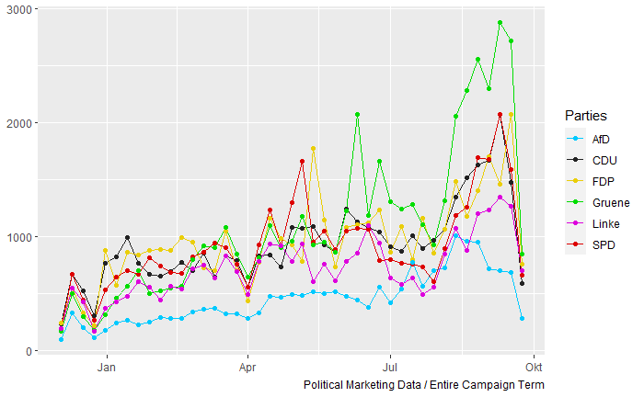

*Figure 2: Total volume of tweets by the political marketing accounts in the campaign period (own*

*representation)*

The main takeaways (figure 2, tables 2 and 3) derived from the overview of the collected data are presented in the following. The full summary statistics and additional descriptive visualizations can be found in Appendix B.

As figure 2 displays, apart from two short-term sharp declines in volume around Christmas 2020 and early April 2021, it can be observed that all six major parties steadily increased their tweet volume approaching the 2021 federal elections - especially the Greens intensified their efforts within the last four weeks. As table 2 displays, the Social Democrats (SPD) exhibit the highest average favorite and followers count, whereas the Greens have the highest average retweet and friends count. It is also noteworthy that only the fringe parties (AfD & The Left) have a tweet without hashtag share that is considerably below 50 percent.

|  |  |  |  |  |  |  |
| --- | --- | --- | --- | --- | --- | --- |
| **Table 2 – Political Marketing Data (65 variables x 218,256 observations)**  *Summary statistics (own representation)* | | | | | | |
| **ID Variables** | **Time Variables** | **Text Variables** | **Location Variables** | **Analysis Variables** | **Dummy Variables** | **Count & Type Variables** |
| user_id, reply_to_status_id, reply_to_user_id,  mentions_user_id, retweet_status_id,  retweet_user_id,  retweet_name, mentions_screen_name,  name | created_at, retweet_created_at, account_created_at | text, hashtags, retweet_text description | location, retweet_location | party_id, election_id, campaign_id, M_syuzhet, M_bing, M_afinn, M_nrc, M_Sentiment_Index, anger, anticipation, disgust, fear, joy, sadness, surprise, trust, positive, negative, Polarity_Index, Emotion_Index, Intensity_Index | is_quote, is_retweet, AfD, CDU, FDP, Gruene, Linke, SPD | favorite_count, retweet_count, followers_count, friends_count, retweet_favorite_count, retweet_retweet_count, retweet_followers_count, retweet_friends_count, urls_url, media_url, media_type, photo, ext_media_url, verified, retweet_verified |
| **Party** | **SPD** | **CDU/CSU** | **Greens** | **FDP** | **AfD** | **Left** |
| **Observations** | 39435 | 40133 | 47116 | 41364 | 19361 | 30847 |
| **Tweet Contents** |  |  |  |  |  |  |
| Tweet WordClouds |  |  |  |  |  |  |
| Most Used Words | 1. spd (2987)  2. geht (1841)  3. cdu (1761)  4. menschen (1648)  5. mal (1505)  6. schon (1423)  7. danke (1393)  8. innen (1373)  9. dann (1354)  10. laschet (1250) | 1. deutschland (2166)  2. cdu (1974)  3. corona (1899)  4. geht (1743)  5. menschen (1699)  6. spd (1557)  7. wollen (1423)  8. danke (1351)  9. gibt (1285)  10. mio (1251) | 1. klimaschutz (3617)  2. menschen (2728)  3. geht (2208)  4. cdu (2201)  5. btw (1994)  6. laschet (1985)  7. bundesregierung (1923)  8. wollen (1915)  9. bundestag (1899)  10. innen (1856) | 1. fdp (3225)  2. vielzutun (1924)  3. corona (1852)  4. deutschland (1688)  5. geht (1654)  6. menschen (1638)  7. dann (1551)  8. immer (1514)  9. schon (1488)  10. gibt (1461) | 1. afd (7674)  2. deutschland (1619)  3. bundestag (1564)  4. corona (1301)  5. btw (925)  6. deutschland-abernormal (842)  7. merkel (830)  8. kinderkongress (793)  9. schon (758)  10. cdu (735) | 1. menschen (2137)  2. linke (1838)  3. bundesregierung (1493)  4. cdu (1461)  5. bundestag (1439)  6. btw (1361)  7. geht (1254)  8. corona (1206)  9. deutschland (1173)  10. gibt (1127) |
| **Reach (per Account)** |  |  |  |  |  |  |
| Avg. Favorite Count | 144.91 | 60.75 | 91.82 | 61.07 | 133.40 | 62.76 |
| Avg. Retweet Count | 85.89 | 83.26 | 138.33 | 74.47 | 107.26 | 88.03 |
| Avg. Followers Count | 62224.65 | 46932.89 | 44464.20 | 29245.91 | 23505.91 | 35611.61 |
| Avg. Friends Count | 1407.92 | 1305.86 | 2048.05 | 1768.77 | 945.58 | 1192.26 |
| **Dissemination (per Account)** | |  |  |  |  |  |
| Avg. Text Width | 149.30 | 151.39 | 153.11 | 152.85 | 167.88 | 173.52 |
| Avg. Hashtag Count | 0.82 | 0.93 | 1.07 | 0.92 | 1.86 | 1.34 |
| Tweets with no hashtag | 58.39% | 53.46% | 49.16% | 55.60% | 41.53% | 40.61% |
| Most Used Hashtags  (for all accounts) | 1. #spd (835)  2. #triell (575)  3. #laschet (519)  4. #scholzpacktdasan (452)  5. #corona (424)  6. #cdu (407)  7. #bundestag (362)  8. #btw21 (322)  9. #klimaschutz (251)  10. #sauerland (227) | 1. #corona (820)  2. #wegenmorgen (647)  3. #btw21 (523)  4. #cdu (521)  5. #triell (456)  6. #afghanistan (431)  7. #bundestag (430)  8. #spd (380)  9. #scholz (337)  10 .#bundeswehr (317) | 1. #klimaschutz (1339)  2. #btw21 (1076)  3. #laschet (1027)  4. #triell (863)  5. #afghanistan (861)  6. #allesistdrin (663)  7. #bundestag (648)  8. #scholz (583)  9. #cdu (514)  10. #corona (448) | 1. #vielzutun (1206)  2. #fdp (1039)  3. #corona (814)  4. #bpt21 (586)  5. #bundestag (583)  6. #btw21 (541)  7. #bundesregierung (372)  8. #afghanistan (307)  9. #eu (305)  10. #lockdown (286) | 1. #afd (5139)  2. #bundestag (1064)  3. #corona (779)  4. #deutschland-abernormal (627)  5. #deutschland (545)  6. #abernormal (498)  7. #merkel (486)  8. #berlin (446)  9. #btw21 (438)  10. #lockdown (432) | 1. #btw21 (664)  2. #bundestag (660)  3. #afghanistan (632)  4. #corona (625)  5. #cdu (611)  6. #machtdasland-gerecht (513)  7. #bundesregierung (478)  8. #dielinke (451)  9. #linke (414)  10. #mietendeckel (406) |

|  |  |  |  |  |  |  |
| --- | --- | --- | --- | --- | --- | --- |
| **Table 3 – User Generated Discussions Data (70 variables x 297,775 observations)**  *Summary statistics (own representation)* | | | | | | |
| **No Party** | **SPD** | **CDU/CSU** | **Greens** | **FDP** | **AfD** | **Left** |
| 118438 | 19127 | 67417 | 19509 | 10966 | 54907 | 7411 |
| **Reach & Dissemination (per Account)** | |  |  |  |  |  |
| Avg. Favorite Count | 2.85 | 2.38 | 2.87 | 3.26 | 2.51 | 2.61 |
| Avg. Retweet Count | 99.97 | 127.04 | 95.58 | 162.23 | 97.05 | 32.96 |
| Avg. Text Width | 148.96 | 156.19 | 151.68 | 147.90 | 147.52 | 154.53 |

**Chapter 6. Methodology**

**Sentiment & Emotion Analysis**

The sentiment and emotion analysis was conducted with the Syuzhet Package. This package enables sentiment extraction based on four different sentiment lexicons (Syuzhet, Afinn, Bing, and NRC) (Jockers 2020). Additionally, the package enables the extraction of emotions with the NRC Emotion Lexicon. Usable in over 40 languages, including German, this lexicon annotates words (also called unigrams) with their associations with two sentiments (positive, negative) and eight emotions (anger, anticipation, disgust, fear, joy, sadness, surprise, and trust). The lexicon was developed manually by two computational linguists and crowdsourcing (Mohammad & Turney 2013, Jockers 2020). The computation of sentiments and emotions is simple: the words of the character input vector (in this case: a singular tweet) are aligned with the words in the respective lexicon. If a word in the input vector matches a word in the lexicon, the annotation of the word is added to the respective tweet. If a sentiment or emotion applies multiple times in a singular tweet, the algebraic sum is added to the respective tweet (Naldi 2019). As formulas 1 and 2 display, two additional indices were created to add a simplified basis for interpreting the analysis results.

**Sentiment Index**. measures the avg. sentiment score of the deployed lexicons per tweet.

$$SENI=\frac{Syuzhet+Bing+Afinn+NRC}{4}$$

**Intensity Index**. measures the sum of deployed emotions per tweet.

$$INTI=\frac{\sum{Emotion Scores}}{8}$$

**Stance Analysis**

In this research, **stances** refer to the relative positioning of parties based on their wordscores. Wordscores are a commonly utilized content analysis method for inferring policy positions for virgin documents based on the scores for words from documents with known scores. Hence, wordscores display a method that can be deployed to attain a relative positioning of parties based on their used language (Lowe 2017). The method utilized in this research generally follows three steps.

Firstly, reference texts (e.g., 2017 party programs) are obtained with a priori known positions. These a priori positions can be derived from expert evaluations. This research utilized two expert evaluations for comparative purposes: the Manifesto Corpus and the 2019 Chapel Hill Expert Survey (Burst et al. 2021, Jolly et al. 2019).

The **Manifesto Corpus** is a multilingual, annotated collection of electoral programs, supported by the two leading German scientific organizations Wissenschaftszentrum für Berlin (WZB) and Deutsche Forschungsgemeinschaft (DFG) (Burst et al. 2021, WZB 2021, DFG 2021). The Manifesto Corpus was chosen as an expert evaluation because its CMP coding (left-to-right positioning score) directly applies to specific party program texts. The **2019 Chapel Hill Expert Survey** contains evaluations and trend files (1999-2019) of 277 parties on political ideology. The 2019 Chapel Hill Expert Survey was chosen because it is the most comprehensive expert survey on political parties in Europe (Jolly et al. 2019). In this research, the Manifesto Corpus was utilized to determine the ideological position of parties for each federal election since 1990. However, because its CMP coding operationalizes left-wing positionings with negative scores, it cannot be utilized in the wordscore algorithm (Quanteda 2021). Hence, the 2019 Chapel Hill Expert Survey was deployed as reference scores for the 2017 party programs instead because it operationalizes with a scale of 0 to 10. In this scale, the value 0 represents holistically left, and the value 1 represents holistically right (Jolly et al., 2019).

Secondly, wordscores are generated from the reference texts. Thirdly, the to-be-scored “virgin” texts are scored using the previously attained wordscores (Laver et al. 2002, Burst et al. 2021, Jolly et al. 2019). The usage of corpora and document-feature matrices is essential for deploying stance analysis. A **corpus** represents the storage library for the UTF-8 encoded text derived from the original documents, along with meta-data at corpus- and document-level. Hence, a corpus is the data source for a **document-feature matrix (DFM)**, in which the documents represent the rows and the features (broad term analysis variables, e.g., syntactic dependencies) are displayed by the columns. Subsequently, each row displays one unit of analysis, and each column represents one analysis variable. For stance analysis, the text in document-feature matrices must be prepared by tokenization, lower-casing texts, and removing punctuation and stopwords. **Tokenization** refers to the extraction of singular, unique words as ‘tokens’ and consequently represents one of the essential requirements for computing text similarities and similarity between authors (Quanteda 2021a).

**Lexical Diversity**

Lexical Diversity can be measured based on the same tokenized document-feature matrix (DFM) as the general stance analysis wordscores. The measure calculates the lexical richness based on the number of unique types of tokens and the length of a document. It is a valuable indicator to measure linguistic skills or the complexity of ideas (Quanteda 2021b, Quanteda 2021c).

**Similarity Between Authors (SBA)**

The measurement of Similarity Between Authors requires grouping the document-feature matrix by a specific entity. This research applied the Twitter handle (also known as screen name) as the grouping entity. This approach enables us to calculate the similarity between authors within each party. The SBA measures the proportion of shared tokens across authors and constructs a distance matrix out of it. This distance matrix can be visualized with dendrograms (Quanteda 2021d).

**Topic-Specific Stance Analysis**

The general stance analysis generates wordscores for the 2021 party programs and campaign tweets based on the reference texts (2017 party programs) and their reference scores. The topic-specific stance analysis uses the campaign tweets and their score as the reference material for the tweets solely about the specific topics.

**Chapter 7. Results**

In the following, the results of this research are presented. Every table and graph can also be found with additional information in Appendix B.

**7.1 Sentiment & Emotion Analysis**

|  |  |  |  |  |  |  |
| --- | --- | --- | --- | --- | --- | --- |
| **Table 4 – Sentiment Index (SENI) and Intensity Index (INTI)**  *Average index score for each party. Highest (green) and lowest scores (red) are highlighted (own rep.).* | | | | | | |
| **Party** | **SPD** | **CDU/CSU** | **Greens** | **FDP** | **AfD** | **Left** |
| SENI Sent. Strategy | **-0.6251** | -0.6292 | -0.6772 | -0.6981 | -0.7348 | **-0.8205** |
| SENI Public Image | -0.7552 | -0.7963 | **-0.7209** | -0.7894 | -0.7681 | **-0.9238** |
| INTI Emot. Strategy | 0.8718 | 0.8766 | 0.8803 | **0.8609** | 0.8767 | **0.9161** |
| INTI Public Image | **1.1318** | 0.9679 | **0.8249** | 1.0771 | 0.9766 | 0.8699 |

This research provides empirical evidence that sentiments and emotions expressed in tweets differ depending on parties and lead candidates (hypothesis 1). In line with current research, table 4 shows that the two incumbent government parties (CDU/CSU & SPD) have utilized more positive sentiment than the opposition parties (Crabtree et al. 2020). Compared to the public image in the user-generated discussions, this picture changes. Whereas the Social Democrats (SPD) have the second most positively connoted public image behind the Greens, only the Left has more negatively connoted tweets than the Conservatives (CDU/CSU). The sentimental and emotive strategy of the fringe parties displays the expected results (hypothesis 2): the Left exhibits the highest scores for negative sentiment and the emotion sadness. The Alternative (AfD) showcases the lowest score for positive sentiment and the highest scores for the emotions anger, disgust, and fear in their political marketing activities (see fig. 3 and table 4).

The comparison between the emotive strategies and the induced emotions in user-generated discussions is also intriguing. All parties induce more emotions in the user-generated discussions than their emotive strategy in the political marketing utilized: the Greens are the notable exception here, as they induce fewer emotions in the user-generated discussions than their emotive strategy displays. Interestingly, Social Democrats (SPD) and Liberal Democrats (FDP) utilized the two most minor amounts of emotions in their strategies. However, they induced the two highest amounts in the user-generated discussions. The epistemic value expressed in the utilization of the emotion surprise played a crucial role for the Social Democrats (SPD). They display the highest score for this emotion both in their marketing activities and user-generated discussions. Additionally, as it pertains to the Left and the Greens, their emotive strategy almost matches their public image in terms of emotions.

|  |  |
| --- | --- |
| **Social Democrats (SPD)**  Emotive Strategy (red)  Public Image (golden) | **Conservatives (CDU/CSU)**  Emotive Strategy (red)  Public Image (golden) |
| **Greens**  Emotive Strategy (red)  Public Image (golden) | **Liberal Democrats (FDP)**  Emotive Strategy (red)  Public Image (golden) |
| **Alternative (AfD)**  Emotive Strategy (red)  Public Image (golden) | **The Left**  Emotive Strategy (red)  Public Image (golden) |

*Figure 3: Average emotion score for each party. Emotive Strategies (red) of the political marketing in comparison with the public perception in the user-generated discussions (golden) (own rep.).*

|  |  |
| --- | --- |
| **Social Democrats (SPD)**  Olaf Scholz (red) | **Conservatives (CDU/CSU)**  Alexander Dobrindt (red)  Armin Laschet (golden) |
| **Greens**  Annalena Baerbock (red)  Robert Habeck (golden) | **Liberal Democrats (FDP)**  Christian Lindner (red) |
| **Alternative (AfD)**  Tino Chrupalla (red)  Alice Weidel (golden) | **The Left**  Dietmar Bartsch (red)  Janine Wissler (golden) |

*Figure 4: Public Party and Candidate Images expressed in emotions (own rep.).*

Comparing figure 3 and 4, the Alternative (AfD) and its two lead candidates induce considerably fewer emotions as the party utilized in their marketing activities. The tweets about lead candidate Alice Weidel (AfD) are most positively connoted out of all lead candidates in the Sentiment Index, subsequently being perceived similarly positive as Christian Lindner (FDP), who displays the highest amount of positive sentiment. These results indicate that the lead candidates of incumbent opposition parties (Greens, Left, FDP & AfD) were rewarded with a positively connoted image of their lead candidates for their criticism of current politics by the incumbent government (CDU/CSU & SPD). Additionally, even though Laschet (CDU) was the target of situational contingency (e.g., #laschetdarfnichtkanzlerwerden), Dobrindt (CSU) was perceived considerably worse in the public eye, displaying the worst overall public candidate image in terms of sentiments and emotions. This public image of Dobrindt could be one of the drivers for the lack of success in the campaign of the Christian Democrats (CDU/CSU). This conclusion would be an angle that has hardly been covered in the public review of the campaigns yet.

**7.2 General Stance Analysis**

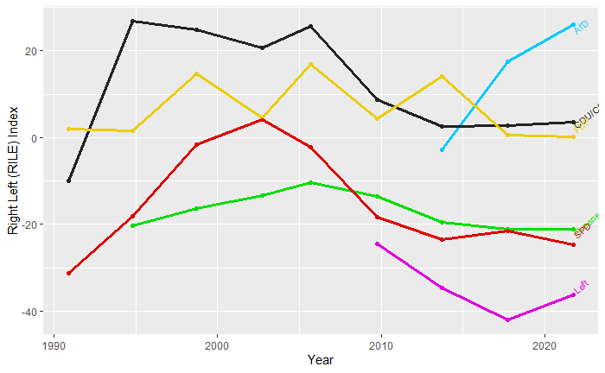

*Figure 5: Relative Positioning of Major German Parties based on their overall ideological position (1990-2021). Measured with the ManifestoR RILE Index based on party programs for each federal election (own representation based on Burst et al. 2021)*

This research utilizes two sources for the relative positioning of parties. Firstly, the Manifesto Corpus is deployed to attain the relative positioning based on the overall ideological position. Secondly, the 2019 Chapel Hill Expert Survey is exerted to attain the relative positioning based on their wordscores.

As figure 5 displays, the ManifestoR RILE Index indicates that the democratic middle of Conservatives (CDU/CSU), Liberal Democrats (FDP), Greens, and Social Democrats (SPD) have roughly maintained their ideological positions from 2017 with their respective 2021 party programs. The Alternative (AfD) has opted for a right-wing shift and a more radical ideological position. In contrast, their left-wing counterpart, the Left, chose to abate some of their 2017 positions for a more moderate ideological position in 2021.

|  |  |  |  |  |  |
| --- | --- | --- | --- | --- | --- |
| **Table 5 – Reference Scores**  *Initial scores for ideological positioning of the reference texts (2017 party programs). Scores are derived from the average overall ideological score of the 2019 Chapel Hill Expert Survey (own rep. based on Jolly et al. 2019).* | | | | | |
| **SPD** | **CDU/CSU** | **Greens** | **FDP** | **AfD** | **Left** |
| 3.619 | 6.524 | 3.238 | 6.429 | 9.238 | 1.429 |

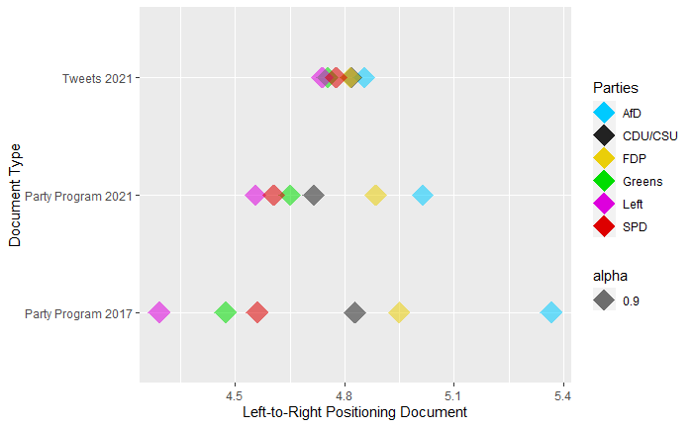

*Figure 6: Relative Positioning of Major Political Parties based on their general wordscores (own rep.).*

As figure 6 displays, the relative positionings of 2017 party programs, 2021 party programs, and campaign tweets from December 2020 to September 2021 offer several interesting insights. Firstly, the left-to-right range in relative positioning has decreased between the 2017 and 2021 party programs by 42.69%, from 1.0757 to 0.4592. Secondly, the left-to-right range decreased even further from the 2021 party programs compared to the campaign tweets by 24.93% from 0.4592 to 0.1145. These results indicate that between 2017 and 2021, the used wordings in party programs and tweets have assimilated across all parties, resulting in a very similar relative wordscore positioning for all parties. Thirdly, the relative positioning of all documents indicates that the political language in Germany is slightly skewed to the left: the median wordscore (4.797) for all documents is allocated on the left of the political middle equivalent value of 5. The used Chapel Hill scale ranges from the value 0 representing holistically left-wing to the value 10 representing holistically right-wing positioning. Fourthly, as established in the general stance analysis (fig. 5), the Alternative (AfD) has been evaluated to have conducted a right-wing ideological shift between the 2017 and 2021 federal elections (Burst et al. 2021). Possibly controversially, this research also indicates that they performed this right-wing shift with a simultaneous left-wing shift in wordscores (fig. 6).

|  |  |  |  |  |  |  |
| --- | --- | --- | --- | --- | --- | --- |
| **Table 6 – Lexical Diversity**  *Calculated for party programs (PP) and campaign tweets (T). Highest (green) and lowest scores (red) are highlighted (own rep.).* | | | | | | |
| **Party** | **SPD** | **CDU** | **Greens** | **FDP** | **AfD** | **Left** |
| PP 2017 | 0.4622 | 0.4392 | **0.3959** | 0.4728 | **0.6152** | 0.5036 |
| PP 2021 | 0.4905 | **0.3969** | 0.4087 | 0.4960 | **0.6035** | 0.4686 |
| T 2021 | 0.1279 | 0.1200 | **0.1047** | 0.1181 | **0.1619** | 0.1222 |

|  |  |  |  |  |  |  |
| --- | --- | --- | --- | --- | --- | --- |
| **Table 7 – Similarity Between Authors (SBA)**  *Differences in text similarity translate into distance between authors.The respective party dendrograms can be found in Appendix B. Highest (green) and lowest scores (red) are highlighted (own rep.).* | | | | | | |
| **Party** | **SPD** | **CDU** | **Greens** | **FDP** | **AfD** | **Left** |
| Max. Dist. | **767.30** | 518.83 | 714.76 | 574.00 | **454.81** | 578.57 |
| Median Dist. | 196.60 | 202.20 | 233.52 | 222.94 | **145.30** | **257.82** |
| Mean Dist. | 219.40 | 209.23 | 270.75 | 242.75 | **176.66** | **281.75** |
| IQR Dist. | 137.10 | 166.89 | 137.10 | **124.05** | 167.02 | **180.06** |
| Min. Dist. | **13.00** | 13.42 | 34.42 | 23.77 | 15.03 | **41.61** |

The results for lexical diversity and similarity between authors are surprising. As table 6 displays, the lexical diversity of all parties has decreased between 2017 and 2021 party programs, and again in comparison to the campaign period tweets. Particularly the Alternative (AfD) proves to be a difficult conundrum to interpret. As table 7 displays, the Alternative (AfD) showcases remarkable coherence among their candidates with the highest Similarity Between Authors (SBA). This result is surprising, as the party also scores the highest lexical diversity, indicating the most voluble language of all parties. This counterintuitive pairing of the highest SBA and lexical diversity for the Alternative (AfD) could indicate considerably higher coordination in the contents and dissemination of tweets compared to the other parties to achieve this result. However, a deviation might have been caused by the smaller sample size for the Alternative (19,361 observations) compared to the sample sizes of the other five parties (30,847-47,116 observations, respectively).

**7.3 Topic-Specific Stance Analysis**

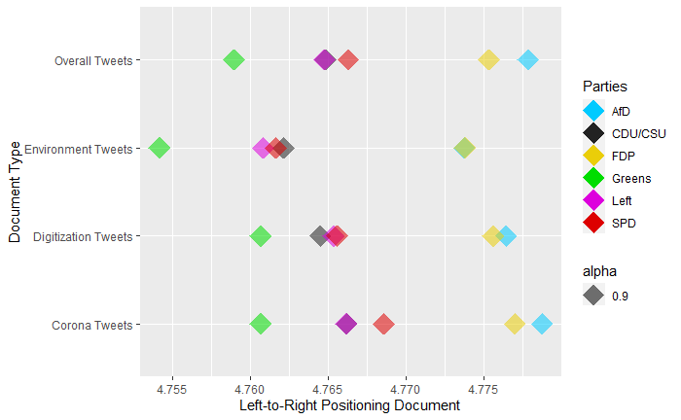

*Figure 7: Topic-specific tweet stances for the topics Corona, Environment and Digitization in comparison to the respective overall stances for all tweets (own rep.).*

Similar to the findings of Giavazzi et al. 2020, this research provides empirical evidence that there were several intriguing shifts in topic-specific stances in regards to the topics of the Covid-19 pandemic (topic 1), environment (topic 2), and digitization (topic 3) by the six major political parties (hypothesis 3). The results indicate that two major exogenous events played a crucial role in the political marketing activities within the campaign term, which enables a rough distinction of the campaign activities into three phases: the Covid-19 lockdown and the floods in western Germany.

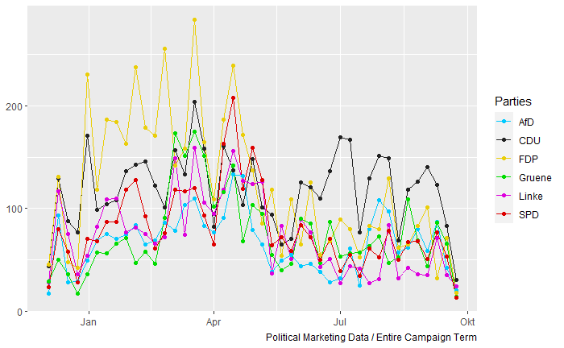

*Figure 8: Volume of Corona-related tweets during the entire campaign period (own rep.).*

The **first campaign phase (Dec. 2020 – Apr. 2021)** was predominantly determined by the alternate living conditions resulting from the regulations of the “hard“ Covid-19 lockdown (Wiwo 2021b). As figure 8 displays, particularly the Liberal Democrats (FDP) and Alternative (AfD) exercised an intensified volume of covid-19-specific tweets compared to other parties' efforts in this time frame. This finding is also reflected in the corona-specific stances, indicating a shift in text-similarity (figure 7). Arguably led by the most right-wing stances of FDP and AfD, the corona-specific tweets of all parties are positioned more right-wing than their respective overall tweet stances. With the lockdown expiring in April 2021, the volume of corona-related tweets considerably decreased, just like the public opinion leadership changed, which was now taken by the Conservatives (CDU/CSU) measured in tweet volume up until the elections.

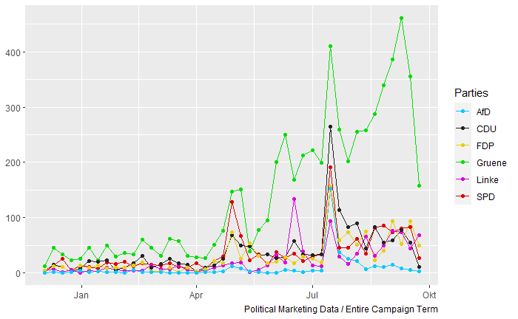

*Figure 9: Volume of environment-related tweets during the entire campaign period (own rep.).*

The **second campaign phase (May 2021 – Aug. 2021)** marks the replacement of Corona as the predominant campaign topic, as the tweet volume for the environment- and climate-change-related tweets drastically increase. Easily identifiable in figure 9: a dramatic, short-term spike in tweet volume at the time of the floods in West Germany and Central Europe in late July 2021 (bpb 2021c). As expected, the Greens pushed this topic forward the most in the public discussion, as their environment-related tweet volume in the second and third campaign phase by far exceeds the efforts of all other parties. This finding can also be measured in stances (figure 7). Arguably led by the most left-wing stances of the Greens, the environment-specific tweets of all parties are positioned more left-wing than their respective overall tweet stances.

The **third campaign phase (Sep. 2021)** characterizes the global maximum of digitization-related tweets volume (figure 10), yet mainly driven by the Conservatives (CDU/CSU). The corresponding stances offer an ambivalent scenery (figure 7): the digitization-specific stances of Conservatives (CDU/CSU), Social Democrats (SPD), and the Alternative (AfD) display a more left-wing relative positioning compared to their respective overall stance positions. In contrast, the topic-specific stances of Liberal Democrats (FDP), the Left, and the Greens are all positioned more right-wing than their respective overall stance positions.

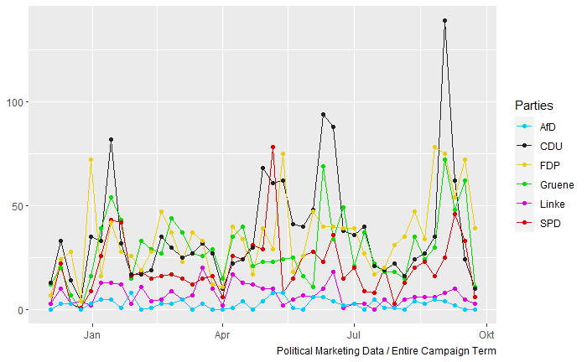

*Figure 10: Volume of digitization-related tweets during the entire campaign period (own rep.)*

**Chapter 8. Discussion**

In this chapter, the results of this research shall be summarized, as well as contextualized with possible interpretations and relevant research findings. To round off this work, the academic and practical relevance of this research is highlighted in the marketing implications (chapter 8.2) and suggestions for future research (chapter 8.3).

**8.1 Summary**

” Every great political campaign rewrites the rules; devising a new way to win is what gives campaigns a comparative advantage against their foes.”

* John Podhoretz (Podhoretz 2021)

Empirical evidence suggests that a substantial amount of voters is susceptible to persuasion: 23% of polled German voters were uncertain of their voting decision two weeks before the election, a similar share of 10 to 20% of undecided voters can also be established in other European countries like Italy and France (Spiegel 2021, Alam & Riva 2019, La Repubblica 2006, Mannheimer 2003). Hence, political marketing should be considered a suitable tool to gain voter support and gain a competitive edge against other parties – particularly in close elections. In characterizing the potential success drivers of Social Democrats (SPD) and Liberal Democrats (FDP), it should be noted that the two parties followed different approaches, likely as a result of their difference in incumbent status (government vs. opposition). The Social Democrats (SPD) generated the highest interaction in terms of favorite and follower counts per candidate profile with the shortest and most positively connoted tweet texts. The epistemic value expressed in the utilization of the emotion surprise played a crucial role for the Social Democrats (SPD). They display the highest score for this emotion both in their marketing activities and user-generated discussions. Embodying the motif of freedom, The Liberal Democrats (FDP) positioned themselves as the arguable public opinion leader in the topics of the Covid-19 pandemic with their stances against lockdown measures - thereby criticizing the activities of the incumbent government (FDP 2021b, FDP 2021c, Welt 2021).

The results of this research allow several fascinating interpretations. Firstly, the increasing text similarity across parties could result from a political power struggle in which all parties attempted to gain voter support in the “middle“ of society. This conclusion is arguable because the fringe parties entered into a competition with the more centralistic parties for the same voter groups by displaying similar stances and similar language. Subsequently, it would represent a development in which parties would be less discernable by contentwise stances and wordings. However, this interpretation requires further empirical evidence. Secondly, the simultaneous shifts of intensified right-wing ideology and left-wing language could indicate that the right-wing Alternative (AfD) attempted to mask their more radical views with more moderate language, arguably hiding their actual positions. Thirdly, the counterintuitive pairing of the highest SBA and lexical diversity for the Alternative (AfD) could indicate considerably higher coordination in the contents and dissemination of tweets compared to the other parties to achieve this result. These particular indications would be in line with the presented contemporary research. Researchers were able to link the majority of hate-speech creating accounts on social media to the Alternative (AfD) and Identarian Movement. Additionally, they were able to identify a high degree of coordination for those two groups on various social media platforms (Geschke et al., 2019, Kreißel et al., 2018).

**8.2 Marketing Implications**

” Everyone wants reactions. Nobody posts anything to be happy afterwards that they have exactly zero comments under it. And to what do we all react the most? Negative messages.”

* Robert Habeck (Greens), new vice chancellor in the traffic light coalition in Germany, about his view of the role that social media plays in modern politics (Feldenkirchen 2021)

In general, using situational contingency was a popular tool to decrease the eligibility of particular candidates and parties in the 2021 campaigns. Arguably successful, as both major implementations have been proposed as drivers for substantial voter fluctuation. On the one hand, there is the supposedly terrifying “slide to the left” expressed in a very left-oriented government coalition (SPD, Greens & Left) stirred up by the Conservatives (CDU/CSU) days before the election. On the other hand, there are individual campaigns against supposedly unbearable candidates Laschet (CDU/CSU), Baerbock (Greens), and Scholz (SPD) (Kahrs 2021). Closely before the elections, polls regarding the perceptions of the lead candidates underlined the potential importance of social imagery in voting decisions. While the majority of polled voters attested Social Democrat Olaf Scholz (67%) the aptitude for the position of chancellor, his rivals Armin Laschet (29%) and Annalena Baerbock (23%) were perceived considerably less qualified for the position. The same picture arises in the individual chancellor preferences, where eventual chancellor Olaf Scholz (48%) was perceived more favorable than his adversaries Armin Laschet (24%) and Annalena Baerbock (14%) combined (Forschungsgruppe Wahlen 2021).

However, it should be noted that these perceptions changed considerably over time. As figure 11 displays, all three candidates were perceived as the most preferential at some time (Eckstein et al., 2021, Wahlen 2021, bpb 2021c). The eventual chancellor Olaf Scholz (SPD) gained his lead in preference in August 2021 after his adversaries suffered from personal controversies. On June 29th, 2021, plagiarism allegations against Annalena Baerbock (Greens) were made regarding her recently published book “Jetzt. Wie wir unser Land erneuern” (Dake 2021). A couple of weeks prior to this, the lead candidate of the Greens was criticized for imprecise and false claims in her published curriculum vitae (Gensing 2021). As previously presented, the public image of Armin Laschet (CDU/CSU) suffered from the laughter at the catastrophe site of the floods during a speech of the German president Steinmeier, which was widely perceived as misplaced in the public discussion (Lütz 2021, Handelsblatt 2021). Interestingly, similarly negative publicity of Olaf Scholz’s involvement in the CumEx tax scandal did not cause a substantial decrease in popularity (Ott 2021, Finanzwende 2021).

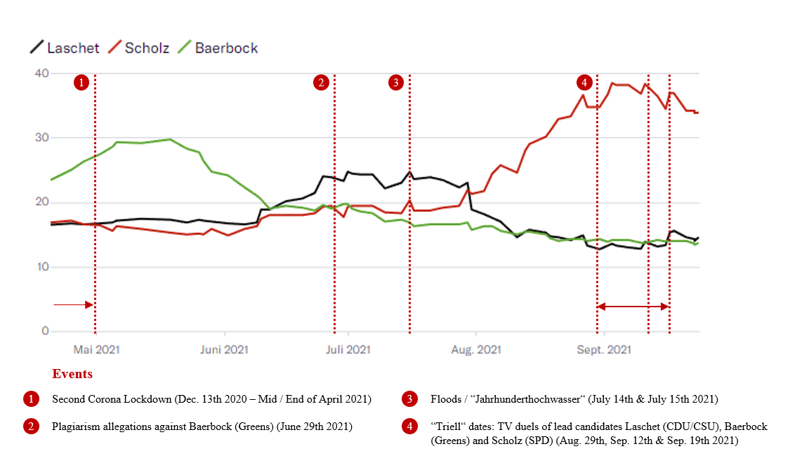

*Figure 11: Polled preferences for the chancellor position in a comparison between lead candidates Armin Laschet (CDU), Annalena Baerbock (Greens) and Olaf Scholz (SPD). (Sources: Eckstein et. al. 2021, Wahlen 2021, bpb 2021c)*

In the three TV duels (called “Triell”), Olaf Scholz (SPD) prevailed his status as preferred chancellor candidate against his adversaries Annalena Baerbock (Greens) and Armin Laschet (CDU/CSU).

|  |
| --- |
|  |

*Figure 12: Regression of Poll Data for the Major Political Parties in the last legislature period (2017-2021). Key events during this time period are marked (Sources: Politico 2021, Bundeswahlleiter 2021f, Eckstein et. al. 2021, Wahlrecht 2021, Wiwo 2021a, Wiwo 2021b, bpb 2021c)*

In summary, multiple practical implications can be derived from these results. Firstly, as the Social Democrats (SPD) and Liberal Democrats (FDP) display, effective political marketing on Twitter is conductible with short texts and low lexical diversity, so the message is easily understandable. Secondly, the question of whether these messages should be in the majority positively or negatively connoted is primarily determined by the incumbent status of parties. Whereas incumbent government parties tend to use positive sentiment to appetize their policies to the public, incumbent opposition parties tend to use negative sentiment to be rewarded for governmental criticism and seen as a suitable political alternative. Thirdly, the public image of the lead candidate seems to be one of the central drivers for voter behavior. As figures 11 and 12 display, the increase in popularity of Social Democrats (SPD) and their chancellor candidate Olaf Scholz happened in similar proportions and timing in August and September 2021. Fourthly, situational contingency and epistemic value seem to be suitable tools to enhance the candidate image. Situational contingency accomplishes the depreciated public perception of opposing candidates while also stressing the differentiating value of the own candidate. Epistemic value offers the opportunity to persuade voters with uncertain voting preferences, as the employed emotion surprise is equipped to gain the voter’s attention.

**8.4 Limitations and Future Research**

While interpreting the results of the sentiment and emotion analysis, the equating of particular sentiments or emotions with value judgments should be done carefully: negative sentiment does not necessarily result in an unfavorable perception (see the incumbent status of government vs. opposition). The same issue is also relevant for stance analysis. Left-wing and right-wing stances are hardly assignable to an unbiased, evaluative scale. While the method of wordscores is a powerful tool, its inherent inefficiencies in measurements have also been covered in contemporary research. Firstly, with being scaled in one dimension (e.g., left to right), the method assumes that parties only represent one side in an issue. However, this assumption often does not hold in reality, especially regarding divisively discussed issues within the party itself (e.g., refugee policies). If applicable, this limitation could be remedied by adding a second dimension (e.g., negative to positive) (Mikhaylov 2009). Secondly, if entire party programs are analyzed with wordscores, the inherent assumption is made that each mentioned topic or policy has the same importance for the parties’ stakeholders. However, this is arguably not true: some policies are more dispensable than others, as the results of coalition negotiations display. Thirdly, the overall absolute position of wordscore positions should be interpreted carefully, as the absolute difference between parties is often only decided by small decimal figures. Hence, this research only analyses the relative changes in stances and not their absolute amounts. This assessment is consistent with contemporary, relevant research: even though the wordscore method generates similar estimates for party positionings in the left-to-right dimension in different countries, the degree of congruence differs considerably across countries, party types, and party programs that they are based on (Bräuninger et al. 2013).

Based on the results of this research, a responsive relationship between tweet volume of parties and exogenous events relevant for election topics can be asserted - as illustrated with the Covid-19 lockdown and July floods (Jahrhunderthochwasser) (bpb 2021c). Additionally, 40 to 60% of the posts by the six major political parties were issued without including hashtags. This finding raises the question of whether the usage of hashtags is necessary for successful political marketing – or if the algorithm already connects users with their searched contents with the usage of intelligent methods like latent semantic scaling (Watanabe 2020). Both findings could be exciting outlines for future research.

**References**

**Alam, M.I. & Riva, F. (2019):** Influence of Political Marketing on Voting Intention: an empirical investigation, University of Dhaka, Bangladesh University of Professionals, p.1-17.

**Allgaier, J. (2020):** Rezo and German Climate Change Policy: The Influence of Networked Expertise on YouTube and Beyond, in: Media and Communication, Vol. 8, Issue 2, pp.376-386.

**Alternative für Deutschland (AfD) (2017):** Programm für Deutschland. Wahlprogramm der Alternative für Deutschland für die Wahl zum Deutschen Bundestag am 24. September 2017. Beschlossen auf dem Bundesparteitag in Köln am 22./23. April 2017, pp.1-76.

**Alternative für Deutschland (AfD) (2021):** Deutschland. Aber normal. Programm der Alternative für Deutschland für die Wahl zum 20. Deutschen Bundestag, pp.1-210.

**Anan, D. (2017):** Parteiprogramme im Wandel. Ein Vergleich von FDP und Grünen zwischen 1971 und 2013, Wiesbaden.

**Bebnowski, D. (2015):** Die Alternative für Deutschland. Aufstieg und gesellschaftliche Repräsentanz einer rechten populistischen Partei, Wiesbaden.

**Betz, H.G. (2020):** The Emotional Underpinnings of Radical Right Populist Mobilization: Explaining the Protracted Success of Radical Right-Wing Populist Parties, CARR Research Insight – Centre for Analysis of the Radical Right, pp.1-42.

**Bond, R.M., Fariss, C.J., Jones J.J., Kramer, A.D.I., Marlow, C. et. al. (2012):** A 61-million person-experiment in social influence and political mobilization, in: Nature, Vol. 489, p.295-298.

**Bösch, F. (2001):** Die Adenauer-CDU. Gründung, Aufstieg und Krise einer Volkspartei 1945-1969, Stuttgart/München.

**Bösch, F. (2002):** Macht und Machtverlust. Die Geschichte der CDU, Stuttgart/München.

**Bösch, F. (2018):** Christlich Demokratische Union Deutschland (CDU), in: Frank Decker / Viola Neu: Handbuch der deutschen Parteien, Volume 3, Wiesbaden, p.242-261.

**Boxell, L. (2017):** The internet, social media, and political polarization, in: Vox EU CEPR, Research-based policy analysis and commentary from leading economists. Retrieved on December 12th 2021. Retrieved from:

https://voxeu.org/article/internet-social-media-and-political-polarisation

**Bräuninger, T., Debus, M. & Müller, J. (2013):** Estimating Policy Positions of Political Actors Across Countries and Time, Mannheim : 2013, Arbeitspapiere – Mannheimer Zentrum für Europäische Sozialforschung, 153, pp.1-28.

**Brechenmacher, T. (2018):** Die CDU unter Angela Merkel (2000-2018), in: Norbert Lammert, Christlich Demokratische Union. Beiträge und Positionen zur Geschichte der CDU, München, p. 81-135.

**Brings, L. & Weber, D. (2021, December 19th):** Impact of Covid-19: Corona as a catalyst for digitization? (Part 3). Careers | CSP Consultant-Team. Retrieved from:

https://www.telekom.com/en/careers/work-in-action/center-for-strategic-projects/trafo-talk/impact-of-covid-19-corona-as-a-catalyst-for-digitalization-part-3--601542

**Bundesministerium des Innern, für Bau und Heimat (2021, October 7th):** Regierungsbildung. Häufig nachgefragt. Retrieved from:

https://www.bmi.bund.de/SharedDocs/faqs/DE/themen/verfassung/regierungsbildung/regierungsbildung-liste.html

**Bundestagswahl 2021a (2021, July 26th):** Wann findet die Bundestagswahl 2021 statt? Termin der Bundestagswahl. Retrieved from:

https://www.bundestagswahl-2021.de/datum/

**Bundestagswahl 2021b (2021, July 26th):** Bundestagswahl 2021: Umfragen, Prognosen und Projektionen. Retrieved from:

https://www.bundestagswahl-2021.de/umfragen/

**Bundestagswahl 2021c (2021, July 27th):** Bundestagswahl 2021: alle teilnehmenden Parteien. Retrieved from:

https://www.bundestagswahl-2021.de/parteien/

**Bundestagswahl 2021d (2021, October 7th**)**:** Bundestagswahl 2021: Ergebnis. Retrieved from:

https://www.bundestagswahl-2021.de/ergebnis/

**Bundestagswahl-BW (BBW) (2021):** Wahlthema. Klima. Umwelt. Retrieved from:

https://www.bundestagswahl-bw.de/wahlthema-klima-umwelt

**Bundeswahlleiter (2021a, July 27th):** 53 Parteien können an der Bundestagswahl 2021 teilnehmen. Pressemitteilung Nr. 14/21 vom 9. Juli 2021. Retrieved from:

https://www.bundeswahlleiter.de/info/presse/mitteilungen/bundestagswahl-2021/14_21_1bwa-entscheidung.html

**Bundeswahlleiter (2021b, October 7th):** Sperrklausel. Retrieved from:

https://www.bundeswahlleiter.de/service/glossar/s/sperrklausel.html#id-0

**Bundeswahlleiter (2021c, October 7th):** Bundestagswahl 2017: Endgültiges Ergebnis. Retrieved from:

https://www.bundeswahlleiter.de/info/presse/mitteilungen/bundestagswahl-2017/34_17_endgueltiges_ergebnis.html

**Bundeswahlleiter (2021d, October 7th):** Wahlkampfphase. Retrieved from:

https://www.bundeswahlleiter.de/service/glossar/w/wahlkampfphase.html

**Bundeswahlleiter (2021e, October 7th):** Wahltermin zum 20. Deutschen Bundestag ist der 26. September 2021. Retrieved from:

https://www.bundeswahlleiter.de/mitteilungen/bundestagswahlen/2021/20201214-wahltermin.html

**Bundeswahlleiter (2021f, November 16th):** Bundestag elections 2021. Retrieved from:

https://www.bundeswahlleiter.de/en/bundestagswahlen/2021/ergebnisse/bund-99.html#stimmentabelle13

**Bundeszentrale für politische Bildung (bpb) (2021a, September 15th 2021):** Kandidatinnen und Kandidaten. Retrieved from:

https://www.bpb.de/nachschlagen/zahlen-und-fakten/bundestagswahlen/339917/kandidierende

**Bundeszentrale für politische Bildung (bpb) (2021b, October 7th 2021):** Bundestag. Retrieved from:

https://www.bpb.de/nachschlagen/lexika/pocket-politik/16362/bundestag

**Bundeszentrale für politische Bildung (bpb) (2021c, December 13th 2021):** Jahrhunderthochwasser 2021 in Deutschland. Retrieved from:

https://www.bpb.de/politik/hintergrund-aktuell/337277/jahrhunderthochwasser-2021-in-deutschland

**Bündnis 90 / Die Grünen (Gruene) (2017):** Zukunft wird aus Mut gemacht. Bundestagswahlprogramm 2017., pp.1-248.

**Bündnis 90 / Die Grünen (Gruene) (2021):** Deutschland. Alles ist drin. Bundestagswahlprogramm 2021. Bereit, weil Ihr es seid., pp.1-272.

**Burst, T., Krause, W., Lehmann, P., Lewandowski, J., Matthieß, T., Merz, N., Regel, S. & Zehnter, L. (2021):** Manifesto Corpus. Version 2021-1. Berlin: WZB Berlin Social Science Center.

**Coppock, A., Hill, S.J. & Vavreck, L. (2020, August 9th):** The small effects of political advertising are small regardless of context, message, sender, or receiver: Evidence from 59 real-time randomized experiments, in: Science Advances, Vol.6, No. 36. Retrieved from:

https://advances.sciencemag.org/content/6/36/eabc4046?intcmp=trendmd-adv

**Chia, S.Y. (2017):** Boost Your Political Campaign with User Generated Content. Sparkle. Retrieved on: December 17th 2021. Retrieved from:

https://getsparkle.io/blog/marketing/boost-your-political-campaign-with-ugc/

**Chou, W., Dancygier, R., Egami, N. & Jamal, A.A. (2021):** Competing for Loyalists? How Party Positioning Affects Populist Radical Right Voting, in: Comparative Political Studies, Vol. 54, Issue 12, pp.2226-2260.

**Christdemokratische Union (CDU/CSU) (2017):** Für ein Deutschland in dem wir gut und gerne leben. Regierungsprogramm 2017-2021, pp.1-76.

**Christdemokratische Union (CDU/CSU) (2021):** Das Programm für Stabilität und Erneuerung. Gemeinsam für ein modernes Deutschland, pp.1-140.

**Crabtree, C., Golder, M., Gschwend, T. & Indridason, I.H. (2020):** It Is Not Only What You Say, It Is Also How You Say It: The Strategic Use of Campaign Sentiment, in: The Journal of Politics, Vol. 82, No. 3, pp. 1-17.

**Dake, B. (2021, June 30th):** Was hinter den Plagiatsvorwürfen steckt. Anschuldigung gegen Baerbock. Retrieved on: December 21st 2021. Retrieved from:

https://www.tagesschau.de/inland/faq-plagiatsvorwuerfe-baerbock-101.html

**Dale, A. & Strauss, A. (2009):** Don’t forget to vote: text message reminders as a mobilization tool, in: American Journal of Political Science, Vol.53, p.787-804.

**Decker, F. (2013):** Das Verhältnis der SPD gegenüber der LINKEN – Die offene Zukunft, in: Gerhard Hirscher / Eckhard Jesse, Extremismus in Deutschland. Schwerpunkte, Vergleiche, Perspektiven, Baden-Baden, p.549-563.

**Decker, F. (2016):** Die “Alternative für Deutschland” aus der vergleichenden Sicht der Parteienforschung, in: Alexander Häusler, Die Alternative für Deutschland, Wiesbaden, p.7-23.

**Decker, F. (2020a):** Aufbruch in unsichere Zeiten. Die CDU am Ende der Ära Merkel.

**Decker, F. (2020b, October 26th):** Kurz und bündig: Die AfD, in: Dossier. Parteien in Deutschland, Bundeszentrale für politische Bildung, Universität Bonn, Institut für Politische Wissenschaft und Soziologie. Retrieved on October 18th 2021. Retrieved from:

https://www.bpb.de/politik/grundfragen/parteien-in-deutschland/afd/211108/kurz-und-buendig

**Decker, F. (2020c, September 9th):** Kurz und bündig: Die Grünen, in: Dossier. Parteien in Deutschland, Bundeszentrale für politische Bildung, Universität Bonn, Institut für Politische Wissenschaft und Soziologie. Retrieved on October 18th 2021. Retrieved from:

https://www.bpb.de/politik/grundfragen/parteien-in-deutschland/gruene/42149/kurz-und-buendig

**Decker, F. (2020d, September 9th):** Kurz und bündig: Die SPD, in: Dossier. Parteien in Deutschland, Bundeszentrale für politische Bildung, Universität Bonn, Institut für Politische Wissenschaft und Soziologie. Retrieved on October 18th 2021. Retrieved from:

https://www.bpb.de/politik/grundfragen/parteien-in-deutschland/spd/42080/kurz-und-buendig

**Decker, F. (2021a, January 5th):** Kurz und bündig: Die FDP, in: Dossier. Parteien in Deutschland, Bundeszentrale für politische Bildung, Universität Bonn, Institut für Politische Wissenschaft und Soziologie. Retrieved on October 18th 2021. Retrieved from:

https://www.bpb.de/politik/grundfragen/parteien-in-deutschland/fdp/42106/kurz-und-buendig

**Decker, F. (2021b, January 5th):** Kurz und bündig: Die Linke, in: Dossier. Parteien in Deutschland, Bundeszentrale für politische Bildung, Universität Bonn, Institut für Politische Wissenschaft und Soziologie. Retrieved on October 18th 2021. Retrieved from:

https://www.bpb.de/politik/grundfragen/parteien-in-deutschland/die-linke/42128/kurz-und-buendig

**Decker, F. (2021c, February 12th):** Kurz und bündig: Die CDU, in: Dossier. Parteien in Deutschland, Bundeszentrale für politische Bildung, Universität Bonn, Institut für Politische Wissenschaft und Soziologie. Retrieved on October 18th 2021. Retrieved from:

https://www.bpb.de/politik/grundfragen/parteien-in-deutschland/cdu/42058/kurz-und-buendig

**Deutsche Forschungsgemeinschaft (DFG) (2021):** DFG Magazin. Retrieved from:

https://www.dfg.de/

**Die Linke (Linke) (2017):** Sozial. Gerecht. Frieden. Für alle. Die Zukunft für die wir kämpfen! Langfassung des Wahlprogramms zur Bundestagswahl 2017., pp.1-144.

**Die Linke (Linke) (2021):** Zeit zu handeln! Für soziale Sicherheit, Frieden und Klimagerechtigkeit. Wahlprogramm zur Bundestagswahl 2021., pp.1-168.

**DW (2021, December 12th 2021):** German election: What are the German party programs? Retrieved from:

https://www.dw.com/en/german-election-what-are-the-german-party-programs/a-59103401

**Eckstein, C., Staub, N., Haas, S. & Thelitz, N. (2021, December 15th):** SPD weiter auf Platz eins, grosse Koalition mit Mehrheit – die neuesten Umfragen zur Bundestagswahl 2021. Wie schneiden die Parteien vor der Bundestagswahl am 26. September ab, und welche Themen sind den Wählern wichtig? Ein regelmäßig aktualisierter Überblick in Zahlen. Neue Züricher Zeitung (NZZ). Retrieved from:

https://www.nzz.ch/international/deutschland/bundestagswahl-2021-die-neusten-umfragen-zur-wahl-in-deutschland-ld.1605950

**Feldenkirchen, M. (2021, December 14th):** Video: Konfrontation: Markus Feldenkirchen trifft Robert Habeck. Retrieved from:

https://www.daserste.de/information/reportage-dokumentation/dokus/videos/konfrontation-video-104.html

**Finanzwende (2021, October 27th):** Chronik von CumEx. Retrieved on: December 21st 2021. Retrieved from:

https://www.finanzwende.de/themen/cumex/chronik-von-cumex/

**Forschungsgruppe Wahlen E.V. (2021, December 15th):** Wahlanalyse Bundestagswahl 2021. SPD-Erfolg und CDU/CSU-Debakel – Kanzlerqualitäten bei Scholz, Skepsis bei Koalitionen. Retrieved from:

https://www.forschungsgruppe.de/Aktuelles/Wahlanalyse_Bundestagswahl/

**Freckmann, M. (2018):** Lindners FDP. Profil – Strategie – Perspektiven, Frankfurt am Main, Otto Brenner Stiftung, Arbeitspapier 29.

**Freie Demokratische Partei (FDP) (2017):** Denken wir neu. Das Programm der Freien Demokraten zur Bundestagswahl 2017: “Schauen wir nicht länger zu.”, pp.1-158.

**Freie Demokratische Partei (FDP) (2021a):** Nie gab es mehr zu tun. Wahlprogramm der Freien Demokraten., pp.1-68.

**Freie Demokratische Partei (FDP) (2021b, December 15th):** Ein Lockdown muss ausgeschlossen werden. Retrieved from:

https://www.fdp.de/ein-lockdown-muss-ausgeschlossen-werden

**Freie Demokratische Partei (FDP) (2021c, December 15th):** Bei Digitalisierung jetzt den Turbo zünden. Digitaltag 2021. Retrieved from:

https://www.fdp.de/bei-digitalisierung-jetzt-den-turbo-zuenden

**Fujiwara, T., Müller, K. & Schwarz, C. (2020):** How Twitter affected the 2016 presidential election, in: Vox EU CEPR, Research-based policy analysis and commentary from leading economists. Retrieved on December 12th 2021. Retrieved from:

https://voxeu.org/article/how-twitter-affected-2016-presidential-election

**Geising, P. & Reisin, A. (2021, December 19th):** Warum viele junge Leute die FPD wählen. Retrieved from:

https://www.tagesschau.de/inland/btw21/fdp-erstwaehler-101.html

**Gensing, P. (2021, June 7th):** Das Netz vergisst nicht. Baerbocks Lebenslauf. Retrieved on: December 21st 2021. Retrieved from:

https://www.tagesschau.de/faktenfinder/baerbock-lebenslauf-101.html

**Geschke, D., Klassen, A., Quent, M. & Richter, C. (2019):** #Hass im Netz. Der schleichende Angriff auf unsere Demokratie. Eine bundesweite representative Untersuchung, Institut für Demokratie und Zivilgesellschaft, Amadeu Antonio Stiftung, Campact – Bewegt Politik, p.4-79.

**Giavazzi, F., Iglhaut, F., Lemoli, G. & Rubera, G. (2020):** Terrorist Attacks, Cultural Incidents and the Vote for Radical Parties: Analyzing Text from Twitter, NBER Working Paper No. 26825, March 2020, Revised November 2020, JEL No. C45, D72, H56, p.3-64.

**Green, D.P., Calfano, B.R. & Aronow, P.M. (2014):** Field experimental designs for the study of media effects, in: Political Communication, Vol. 31, Taylor & Francis, p.168-180.

**Hambauer, V. & Mays, A. (2018):** Wer wählt die AfD? Ein Vergleich der Sozialstruktur, politischen Einstellungen und Einstellungen zu Flüchtlingen zwischen AfD-WählerInnen und der WählerInnen der anderen Parteien, in: Zeitschrift für Vergleichende Politikwissenschaft, 12(1), p.133-154.

**Handelsblatt (2021, July 19th):** Laschet lacht im Krisengebiet – Ein Fettnapf zu viel? Hochwasser in Deutschland. Retrieved on December 19th 2021. Retrieved from:

https://www.handelsblatt.com/politik/hochwasser-in-deutschland-laschet-lacht-im-krisengebiet-ein-fettnapf-zu-viel/27433536.html?ticket=ST-3392833-yRWC7VJeIVbE1ghS2xyY-cas01.example.org

**Häusler, A. & Roeser, R. (2015):** Zwischen Euro-Kritik und rechtem Populismus: Merkmale und Dynamik des Rechtsrucks in der AfD, in: Andreas Zick & Beate Küpper, Wut Verachtung, Abwertung. Rechtspopulismus in Deutschland, Bonn, p.124-145.

**Hastie, R. & Park, B. (1986):** The relationship between memory and judgment depends on whether the task is memory-based or on-line, in: Psychological Review, Vol. 93, pp.258-268.

**Hilje, J. (2021, July 27th):** AfD und Grüne "am besten gerüstet". Digitaler Bundestagswahlkampf. ZDF Retrieved from:

https://www.zdf.de/nachrichten/digitales/wahlkampf-bundestagswahl-parteien-social-media-100.html

**Holzhauser, T. (2019):** Die “Nachfolgepartei”. Die Integration der PDS in das politische System der Bundesrepublik Deutschland 1990 – 2005, Berlin / Boston.

**Hughes, A. & Dann, S. (2006):** Direct Benefit, Value and Managing the Voter Relationship, The Australian National University, p.1-8.

**Jacobsen, G.C. (2015):** How Do Campaigns Matter?, in: Annual Review of Political Science, Vol.18, p.31-47.

**Jaursch, J. (2020):** Rules for Fair Digital Campaigning. Policy Brief. Retrieved on December 16th 2021. Retrieved from:

https://www.stiftung-nv.de/en/publication/rules-fair-digital-campaigning

**Jaursch, J. (2021, December 17th):** Disinformation in the 2021 German Federal Election: What Did and Did Not Occur. Institut Montaigne. Copyright: John MACDOUGALL / AFP. Retrieved from:

https://www.institutmontaigne.org/en/blog/disinformation-2021-german-federal-elections-what-did-and-did-not-occur

**Junginger, B. (2021, July 11th):** Corona-Streit sollte im Wahlkampf besser außen vor bleiben, Augsburger Allgemeine Zeitung. Retrieved on December 18th 2021. Retrieved from:

https://www.augsburger-allgemeine.de/politik/Kommentar-Corona-Streit-sollte-im-Wahlkampf-besser-aussen-vor-bleiben-id60069326.html

**Jockers, M. (2020):** Syuzhet. R Documentation. Retrieved from:

https://www.rdocumentation.org/packages/syuzhet/versions/1.0.6

**Jolly, S., Bakker, R., Hooghe, L., Marks, G., Polk, J., Rovny, J., Steenbergen, M. &**

**Vachudova, M.A. (2019):** “Chapel Hill Expert Survey Trend File, 1999-2019. Electoral Studies. Retrieved from:

https://www.chesdata.eu/2019-chapel-hill-expert-survey

**Kahrs, H. (2021, December 15th):** Breaking Down the 2021 Federal Election. A reshuffling of the political centre and a disaster for the Left, Rosa-Luxemburg Stiftung. Retrieved from:

https://www.rosalux.de/en/news/id/45058/breaking-down-the-2021-german-federal-election

**Klein, M. & Falter, J.W. (2003):** Der lange Weg der Grünen. Eine Partei zwischen Protest und Regierung, München.

**Kleinert, H. (1992):** Vom Protest zur Regierungspartei. Die Geschichte der Grünen, Frankfurt am Main.

**Kleinmann, H. (1993):** Geschichte der CDU 1945-1982, Stuttgart.

**Kreißel, P., Ebner, J., Urban, A. & Guhl, J. (2018):** Hass auf Knopfdruck. Rechtsextreme Trollfabriken und das Ökosystem koordinierter Hasskampagnen im Netz, Institute for Stategic Dialogue (ISD), p.1-30.

**Krell, C. & Woyke, M. (2015):** Die Grundwerte der Sozialdemokratie. Historische Ursprünge und politische Bedeutung, in: Christian Krell / Tobias Mörschel, Werte und Politik, Wiesbaden, p.93-137.

**La Repubblica (2006):** Le intenzioni di voto ai Partiti Il trend di marzo. Retrieved on November 9th 2021. Retrieved from:

https://www.repubblica.it/speciale/2006/elezioni_sondaggi/index.html

**Laver, M., Benoit, K. & Garry, J. (2002):** Extracting Policy Positions from Political Texts Using Words as Data, Trinity College Dublin, pp.1-49.

**Lee, J.S., Choi J., Yoo Y.H., et. al. (2014):** The effect of word imagery on priming effect under a preconscious condition: an fMRI study, in: Hum Brain Mapp., Vol. 35, No. 9, p. 4795-4804.

**Lewandowsky, M. (2018):** Alternative für Deutschland (AfD), in: Frank Decker / Viola Neu, Handbuch der deutschen Parteien, Vol. 3, p.161-170.

**Liberini, F., Redoano, M., Russo, A., Cuevas Rumin, A. & Cuevas Rumin, R. (2018):** Politics in the Facebook era: How reading political ads on Facebook affects our voting behavior (… and helped Trump to win the presidential election), in: Vox EU CEPR, Research-based policy analysis and commentary from leading economists. Retrieved on December 12th 2021. Retrieved from:

https://voxeu.org/article/politics-facebook-era

**Lock, A. & Harris, P. (1996):** Political marketing – vive la différence!, in: European Journal of Marketing, Vol. 30, No. 10/11, MCB University Press, 0309-0566, Faculty of Management and Business, The Manchester Metropolitan University, Manchester, United Kingdom, p.14-24.

**Lodge, M. & Taber, C. (1998):** Three steps toward a theory of motivated political reasoning, in: Elements of Political Reason: Understanding and Expanding the Limits of Rationality, ed. Lupia, A., McCubbins, M., Popkin, S., New York: Cambridge Univ. Press.

**Lösche, P. & Walter, F. (1992):** Die SPD. Klassenpartei – Volkspartei – Quotenpartei. Zur Entwicklung der Sozialdemokratie von Weimar bis zur deutschen Vereinigung, Darmstadt, p.21-25.

**Lovett, M.J. (2019):** Empirical Research on Political Marketing: a Selected Review, in: Customer Needs and Solutions, Vol. 6, p. 49-56.

**Lowe, W. (2017):** Understanding Wordscores, in: Political Analysis, Vol. 16(4), pp.356-371.

**Lütz, M. (2021, August 9th):** Was Armin Laschets Lachen wirklich bedeutet. Retrieved on: December 21st 2021. Retrieved from:

https://www.welt.de/debatte/kommentare/article233018863/Psychologie-der-Macht-Was-Armin-Laschets-Lachen-wirklich-bedeutet.html

**Lynen von Berg, H. (2019):** Der Niedergang der SPD als Volkspartei und ihr hilfsloser Antipopulismus, in: Leviathan 47(1), p.7-27.

**Magnecon (2021, November 7th):** Politische Strategie. Magnecon. Politik. Politische Strategie. Retrieved from:

https://www.magnecon.de/politik/politische-strategie/

**Mannheimer, R. (2003):** Gli italiani e la politica. 2002-2003. Consensi e delusion. Milano: Bompiani.

**Marcus, G.E. (2000):** Emotions in Politics, in: Annual Review of Political Science, Vol.3, p.221-250.

**Matejka, F. & Tabellini, G. (2020):** Political information in the age of the internet, in: Vox EU CEPR, Research-based policy analysis and commentary from leading economists. Retrieved on December 12th 2021. Retrieved from:

https://voxeu.org/article/political-information-age-internet

**McNair, B. (2011):** An introduction to political communication, 5th Edition, London: Routledge, p.94.

**Mikhaylov, V. (2009):** Measurement Issues in the Comparative Manifesto Project Data Set and Effectiveness of Representative Democracy, Dissertation, University of Dublin, Trinity College, pp.1-182.

**Mohammad, S.M. & Turney, P.D. (2013):** Crowdsourcing a Word-Emotion Association Lexicon, Institute for Information Technology, National Research Council Canada. Ottawa, Ontario, Canada, pp.1-25.

**Naldi, M. (2019):** A review of sentiment computation methods with R packages, University of Rome Tor Vergata, Department of Civil Engineering and Computer Science, pp.1-11.

**Neu, V. (2018):** Die Linke, in: Frank Decker / Viola Neu, Handbuch der deutschen Parteien, Vol. 22, Wiesbaden, p.384.401.

**Newman, B.I. (1999a):** Handbook of political marketing. Thousand Oaks, CA: Sage.

**Newman, B.I. (1999b):** The mass marketing of politics: Democracy in an age of manufactured images. Thousand Oaks, CA: Sage.

**Newman, B.I. (1999c):** A predictive model of voter behavior, in: B.I. Newman, Handbook of political marketing. Thousand Oaks, CA: Sage.

**Newman, B.I. & Perloff, R.M. (2004):** Political Marketing: Theory, Research, and Applications, in: Lawrence Erlbaum Associates, Handbook of Political Communication Research / edited by Lynda Lee Kaid, Mahwah, New Jersey, London, p.17-45.

**Nezik, A.K. (2021):** Der Unvollendete. Jack Dorsey verlässt Twitter, jetzt übernehmen die Investore. Das kann die Plattform gar nicht gebrauchen, Die Zeit.

**Niedermayer, O. (2006):** Die Wählerschaft der Linkspartei. PDS 2005: sozialstruktureller Wandel bei gleichbleibender politischer Positionierung, in: Zeitschrift für Parlamentsfragen, 37(3), p.523-538.

**Niedermayer, O. (2015):** Von der dritten Kraft zur marginalen Partei. Die FDP von 2009 bis nach der Bundestagswahl 2013, in: Die Parteien nach der Bundestagswahl 2013, p. 103-104.

**Niedermayer, O. & Hofrichter, J. (2016):** Die Wählerschaft der AfD: wer ist sie, woher kommt sie und wie weit rechts steht sie?, in: Zeitschrift für Parlamentsfragen, 47(2), p.267-284.

**Ott, K. (2021, December 5th):** Gefährlich für Olaf Scholz. Cum-Ex-Steuerskandal, Süddeutsche Zeitung. Retrieved on: December 21st 2021. Retrieved from:

https://www.sueddeutsche.de/meinung/cum-ex-steuerskandal-warburg-olaf-scholz-peter-tschentscher-hamburg-1.5480515

**Park, S., Strover, S., Choi, J. & Schnell, M. (2021, December 10th):** Mind games: A temporal sentiment analysis of the political messages of the Internet Research Agency on Facebook and Twitter, in: New Media & Society, pp.1-22.

**Pfahl-Traughber, A. (2013):** Die Partei des Demokratischen Sozialismus (PDS), DIE LINKE, in: Oskar Niedermayer, Handbuch Parteienforschung, Wiesbaden, p.541-562.

**Podhoretz, J. (2021, December 13th):** Political Campaign Quotes. Retrieved from:

https://www.brainyquote.com/quotes/john_podhoretz_484825?src=t_political_campaign

**Politico (2021, November 16th):** Germany – 2021 general election. Social Democrats narrowly win German vote. Retrieved from:

https://www.politico.eu/europe-poll-of-polls/germany/

**Pollytix (2021, December 16th):** Willkommen beim MdB-Twitter-Netzwerk. Retrieved from:

https://mdb.pollytix.de/

**Probst, L. (2013):** Bündnis 90/Die Grünen (GRÜNE), in: Oskar Niedermayer, Handbuch Parteienforschung, Wiesbaden, p.509-540.

**Probst, L. (2015):** Bündnis 90/Die Grünen: Absturz nach dem Höhenflug, in: Oskar Niedermayer, Die Parteien nach der Bundestagswahl 2013, p.135-158.

**Quadriga (2017, August 8th):** Trendstudie Digital Campaigning in der Bundestagswahl 2017 – Implikationen für Politik und Public Affairs.

Retrieved from:

https://www.medianet-bb.de/wp-content/uploads/2018/01/quadriga-digital-campaigning-studie-btw2017.pdf

**Quanteda (2021a, December 13th):** Quick Start Guide. Retrieved from:

https://quanteda.io/articles/quickstart.html

**Quanteda (2021b, December 19th):** Lexical Diversity. Retrieved from:

https://tutorials.quanteda.io/statistical-analysis/lexdiv/

**Quanteda (2021c, December 19th):** Calculate Lexical Diversity. Retrieved from:

https://quanteda.io/reference/textstat_lexdiv.html

**Quanteda (2021d, December 19th):** Compute Similarity Between Authors. Retrieved from:

https://tutorials.quanteda.io/advanced-operations/twitter-user-similarity/

**Redaktionsnetzwerk Deutschland (RND) (2021):** Böhmermann kritisiert “schmutzige Facebook-Tricks der Parteien”. Retrieved from:

https://www.rnd.de/politik/jan-boehmermann-kritisiert-schmutzige-facebook-tricks-der-parteien-ATF2Q6KUNNDFPBBKGUJKGMCEAQ.html

**Rezo (2021):** Die Zerstörung der CDU. Retrieved from:

https://www. youtube.com/watch?v=4Y1lZQsyuSQ

**Ruhose, F. (2020):** Die AfD vor der Bundestagswahl 2021. Wirkung – Perspektiven – Strategien, Wiesbaden.

**Salmela, M. & von Scheve, C. (2018):** Emotional dynamic of right- and left-wing political populism, pp. 1-35.

**Sears, D.O. (1993):** Symbolic Politics: a socio-psychological theory, in: Explorations in Political Psychology, ed. S. Iyengar, WJ McGuire, Durham, NC: Duke University Press, pp.113-149.

**Schumacher, G., de Vries, C.E. & Vis, B. (2013):** Why Do Parties Change Position? Party Organization and Environmental Incentives, in: The Journal of Politics, Vol. 75, No. 2, University of Chicago, pp.464-477.

**Schweiger, W. (2017):** Der (des)informierte Bürger im Netz. Wie soziale Medien die Meinungsbildung verändern, Wiesbaden: Springer, p. 113.

**Silva, B.C. & Proksch, S.O. (2021):** Politicians unleashed? Political communication on Twitter and in parliament in Western Europe, in: Political Science Research and Methods, pp.1-17.

**Sozialdemokratische Partei Deutschlands (SPD) (2017):** “Zeit für mehr Gerechtigkeit”. Unser Regierungsprogramm., pp.1-88.

**Sozialdemokratische Partei Deutschlands (SPD) (2021):** Aus Respekt vor deiner Zukunft. Das Zukunftsprogramm der SPD. Wofür wir stehen. Was uns antreibt. Wonach wir streben., pp-1.66.

**Spier, T. & von Alemann, U. (2013):** Die Sozialdemokratische Partei Deutschlands (SPD), in: Oskar Niedermayer, Handbuch der Parteienforschung, Wiesbaden, p.439-467.

**Spenkuch, J.L. & Toniatti, D. (2018):** Political Advertising and Election Results, Kelogg School of Management at Northwestern University, p.1-45.

**Spiegel (2021, September 8th):** Große Mehrheit hat Wahlentscheidung schon getroffen. Spiegel Umfrage. Retrieved on November 16th 2021. Retrieved from:

https://www.spiegel.de/politik/deutschland/umfrage-vor-bundestagswahl-ein-fuenftel-der-waehler-noch-unentschlossen-a-05550973-9407-4435-83d1-b4505bb130e7

**Südschleswigscher Wählerverband (SSW) (2021, December 17th):** Über den SSW. Retrieved from:

https://www.ssw.de/die-partei/ueber-den-ssw

**Sunstein, C. (2007):** Sunstein on the internet and political polarization, in: The Chronicle of Higher Education, The University of Chicago, The Law School. Retrieved on December 12th 2021. Retrieved from:

https://www.law.uchicago.edu/news/sunstein-internet-and-political-polarization

**Switek, N. (2012):** Bündnis 90/Die Grünen: Zur Entscheidungsmacht grüner Bundesparteitage, in: Karl-Rudolf Korte / Jan Treibel, Wie entscheiden Parteien?, ZPol-Sonderband, Baden-Baden, p.121-154.

**Tagesschau (2021, August 12th):** Wie Deutschland digitaler werden soll. Wahlprogramme digitaler werden soll. Retrieved on: December 19th 2021. Retrieved from:

https://www.tagesschau.de/inland/btw21/programmvergleich-digitalisierung-111.html

**Tagesspiegel (2021a, August 9th):** Das Social Media Dashboard zur Bundestagswahl 2021. Retrieved from:

https://interaktiv.tagesspiegel.de/lab/social-media-dashboard-bundestagswahl-2021/

**TargetLeaks (2021, December 17th):** Wie die Parteien geheime Daten für ihren Wahlkampf bei Facebook nutzen – hier sind die #TargetLeaks. Retrieved from:

https://targetleaks.de/index

**Tawadrous, M. (2021, December 16th):** Wahlplakat oder Twitter-Post? Die digitale Wahlkampfarena, Der Tagesspiegel. Retrieved from:

https://plus.tagesspiegel.de/wahlplakat-oder-twitter-post-die-digitale-wahlkampfarena-249679.html

**Techopedia (2021, November 9th):** Techopedia Explains User-Generated Content (UGC). Retrieved from:

https://www.techopedia.com/definition/3138/user-generated-content-ugc

**Treibel, J. (2018):** Freie Demokratische Partei (FDP), in: Frank Decker / Viola Neu, Handbuch der deutschen Parteien, Vol. 3, Wiesbaden, p. 319-331.

**UA Alberta (2021, December 10th):** Cluster Analysis. Multivariate Fundamentals: Distance. Retrieved from:

https://sites.ualberta.ca/~lkgray/uploads/7/3/6/2/7362679/slides-clusteranalysis.pdf

**Vollmer, A.M. (2013):** Arbeit & soziale Gerechtigkeit – die Wahlalternative (WASG). Entstehung, Geschichte und Bilanz, Baden-Baden.

**Wahlen_DE (Wahlen) (2021, December 15th):** Deutschland Wählt. Retrieved from:

https://twitter.com/Wahlen_DE

**Wahlrecht.de (Wahlrecht) (2021, December 15th):** Sonntagsfrage Bundestagswahl. Retrieved from:

https://www.wahlrecht.de/umfragen/index.htm

**Walter, F. (2010):** Gelb oder Grün? Kleine Parteiengeschichte der besserverdienenden Mitte in Deutschland, Bielefeld.

**Walter, F. (2018):** Die SPD. Biographie einer Pareti von Ferdinand Lassalle bis Andrea Nahles, Reinbek bei Hamburg.

**Washington State Legislature (WSL) (2021, August 12th):** RCW 42.17A.005. Retrieved from:

https://app.leg.wa.gov/RCW/default.aspx?cite=42.17A.005

**Watanabe, K. (2020):** Latent Semantic Scaling: A Semisupervised Text Analysis Technique for New Domains and Languages, in: Communication Methods and Measures, Vol. 15, Iss. 2, pp.81-102.

**Welt (2021, December 15th):** “Viele Menschen haben sich mehr erwartet als einen frischen Haarschnitt”. Kritik der Opposition. Retrieved from:

https://www.welt.de/politik/deutschland/article226153877/Lockdown-Verlaengerung-Viele-haben-mehr-erwartet-als-einen-frischen-Haarschnitt.html

**Wikimedia (2017):** Bundestagswahl 2017. Erststimmenergebnisse. Retrieved on October 20th 2021. Retrieved from:

https://upload.wikimedia.org/wikipedia/commons/thumb/f/fa/Bundestagswahl_2017_Erststimmenergebnisse.svg/1729px-Bundestagswahl_2017_Erststimmenergebnisse.svg.png

**Wikimedia (2021a):** Erststimmenmehrheiten Bundestagswahl 2021. Retrieved on October 20th 2021. Retrieved from:

https://upload.wikimedia.org/wikipedia/commons/thumb/8/8b/Erststimmenmehrheiten_Bundestagswahl_2021.svg/1720px-Erststimmenmehrheiten_Bundestagswahl_2021.svg.png

**Wikimedia (2021b):** Changes in party list votes from 2017 to 2021 german general elections. Retrieved on October 20th 2021. Retrieved from:

https://upload.wikimedia.org/wikipedia/commons/thumb/2/2a/Changes_in_party_list_votes_from_2017_to_2021_german_general_election.svg/2386px-Changes_in_party_list_votes_from_2017_to_2021_german_general_election.svg.png

**Wikimedia (2021c):** German parliamentary elections diagram. Retrieved on November 10th 2021. Retrieved from:

https://upload.wikimedia.org/wikipedia/commons/thumb/a/a4/German_parliamentary_elections_diagram.svg/1560px-German_parliamentary_elections_diagram.svg.png

**Wired (2016):** “Here’s How Facebook Actually Won Trump the Presidency”.

**WirtschaftsWoche (Wiwo) (2021a):** Wie verlief der erste Lockdown in Deutschland? Corona-Lockdown. Retrieved from:

https://www.wiwo.de/politik/deutschland/corona-lockdown-wie-verlief-der-erste-lockdown-in-deutschland/26853384.html

**WirtschaftsWoche (Wiwo) (2021b):** So ist der zweite Lockdown in Deutschland verlaufen. Corona-Lockdowns. Retrieved from:

https://www.wiwo.de/politik/deutschland/corona-lockdowns-so-ist-der-zweite-lockdown-in-deutschland-verlaufen/27076474.html

**Wissenschaftszentrum Berlin für Sozialforschung (WZB) (2021, December 19th):** Das WZB. Retrieved from:

https://www.wzb.eu/de

**Wolfrum, E. (2013):** Rot-Grün an der Macht. Deutschland 1998-2005, München.

**Zandt, F. (2021, December 17th):** Digitale Wahlwerbung nimmt kaum Fahrt auf. Wahlwerbung auf Social Media. Retrieved from:

https://de.statista.com/infografik/25749/online-werbeausgaben-der-bundestagsparteien-auf-ausgewaehlten-plattformen/

**Zettl, C. (2004):** Die Wähler der Linkspartei. PDS von 1994 bis 2009, Wiesbaden.

**Zolleis, U. & Schmid, J. (2013):** Die Christlich Demokratische Union Deutschlands (CDU), in: Oskar Niedermayer, Handbuch Parteienforschung, Wiesbaden, p. 415-437.

**Appendices**

**Appendix A. Data I**

**Appendix B. Results IV**

**Appendix C. Model-Free Analysis XXI**

**Appendix D. German Political System XXIV**

**GitHub Repository**

https://github.com/philippklaeger/Gaining-The-Competitive-Edge

**Data Sets**

**Before Analysis**

Political Marketing

<https://drive.google.com/file/d/1BtQ1bhOUISmhqDY-fRcXS0X4WJOIXxtL/view?usp=sharing>

User-Generated Discussions

<https://drive.google.com/file/d/1f_QpmKQt2yiO-InzM41nmzIUZBVcgWSw/view?usp=sharing>

**After Analysis**

Marketing

<https://drive.google.com/file/d/1wRvswelFP5wBGvSuMUZUYEEXA4HFxY-j/view?usp=sharing>

Users

<https://drive.google.com/file/d/19eIIgpT3X3k-IXmUdI1dFAkNhccNjYDW/view?usp=sharing>

**Appendix A. Data**

**Data Set 1 – Political Marketing: 65 variables x 218,256 observations**

**Table A1 – Summary Statistics for the Political Marketing Data**

|  |  |  |  |  |  |  |
| --- | --- | --- | --- | --- | --- | --- |
| **ID Variables** | **Time Variables** | **Text Variables** | **Location Variables** | **Analysis Variables** | **Dummy Variables** | **Count & Type Variables** |
| user_id, reply_to_status_id, reply_to_user_id,  mentions_user_id, retweet_status_id,  retweet_user_id,  retweet_name, mentions_screen_name,  name | created_at, retweet_created_at, account_created_at | text, hashtags, retweet_text description | location, retweet_location | party_id, election_id, campaign_id, M_syuzhet, M_bing, M_afinn, M_nrc, M_Sentiment_Index, anger, anticipation, disgust, fear, joy, sadness, surprise, trust, positive, negative, Polarity_Index, Emotion_Index, Intensity_Index | is_quote, is_retweet, AfD, CDU, FDP, Gruene, Linke, SPD | favorite_count, retweet_count, followers_count, friends_count, retweet_favorite_count, retweet_retweet_count, retweet_followers_count, retweet_friends_count, urls_url, media_url, media_type, photo, ext_media_url, verified, retweet_verified |
| **Party** | **SPD** | **CDU/CSU** | **Greens** | **FDP** | **AfD** | **Left** |
| **Observations**  Total: 218256 | 39435 | 40133 | 47116 | 41364 | 19361 | 30847 |
| **Tweet Contents** |  |  |  |  |  |  |
| Tweet WordCloud |  |  |  |  |  |  |
| Most Used Words | 1. spd (2987)  2. geht (1841)  3. cdu (1761)  4. menschen (1648)  5. mal (1505)  6. schon (1423)  7. danke (1393)  8. innen (1373)  9. dann (1354)  10. laschet (1250) | 1. deutschland (2166)  2. cdu (1974)  3. corona (1899)  4. geht (1743)  5. menschen (1699)  6. spd (1557)  7. wollen (1423)  8. danke (1351)  9. gibt (1285)  10. mio (1251) | 1. klimaschutz (3617)  2. menschen (2728)  3. geht (2208)  4. cdu (2201)  5. btw (1994)  6. laschet (1985)  7. bundesregierung (1923)  8. wollen (1915)  9. bundestag (1899)  10. innen (1856) | 1. fdp (3225)  2. vielzutun (1924)  3. corona (1852)  4. deutschland (1688)  5. geht (1654)  6. menschen (1638)  7. dann (1551)  8. immer (1514)  9. schon (1488)  10. gibt (1461) | 1. afd (7674)  2. deutschland (1619)  3. bundestag (1564)  4. corona (1301)  5. btw (925)  6. deutschland-abernormal (842)  7. merkel (830)  8. kinderkongress (793)  9. schon (758)  10. cdu (735) | 1. menschen (2137)  2. linke (1838)  3. bundesregierung (1493)  4. cdu (1461)  5. bundestag (1439)  6. btw (1361)  7. geht (1254)  8. corona (1206)  9. deutschland (1173)  10. gibt (1127) |
| **Reach (per Account)** |  |  |  |  |  |  |
| Avg. Favorite Count | 144.91 | 60.75 | 91.82 | 61.07 | 133.40 | 62.76 |
| Avg. Retweet Count | 85.89 | 83.26 | 138.33 | 74.47 | 107.26 | 88.03 |
| Avg. Followers Count | 62224.65 | 46932.89 | 44464.20 | 29245.91 | 23505.91 | 35611.61 |
| Avg. Friends Count | 1407.92 | 1305.86 | 2048.05 | 1768.77 | 945.58 | 1192.26 |
| **Dissemination (per Account)** | |  |  |  |  |  |
| Avg. Text Width | 149.30 | 151.39 | 153.11 | 152.85 | 167.88 | 173.52 |
| Avg. Hashtag Count | 0.82 | 0.93 | 1.07 | 0.92 | 1.86 | 1.34 |
| Tweets with no hashtag | 58.39% | 53.46% | 49.16% | 55.60% | 41.53% | 40.61% |
| Most Used Hashtags  (for all accounts) | 1. #spd (835)  2. #triell (575)  3. #laschet (519)  4. #scholzpacktdasan (452)  5. #corona (424)  6. #cdu (407)  7. #bundestag (362)  8. #btw21 (322)  9. #klimaschutz (251)  10. #sauerland (227) | 1. #corona (820)  2. #wegenmorgen (647)  3. #btw21 (523)  4. #cdu (521)  5. #triell (456)  6. #afghanistan (431)  7. #bundestag (430)  8. #spd (380)  9. #scholz (337)  10 .#bundeswehr (317) | 1. #klimaschutz (1339)  2. #btw21 (1076)  3. #laschet (1027)  4. #triell (863)  5. #afghanistan (861)  6. #allesistdrin (663)  7. #bundestag (648)  8. #scholz (583)  9. #cdu (514)  10. #corona (448) | 1. #vielzutun (1206)  2. #fdp (1039)  3. #corona (814)  4. #bpt21 (586)  5. #bundestag (583)  6. #btw21 (541)  7. #bundesregierung (372)  8. #afghanistan (307)  9. #eu (305)  10. #lockdown (286) | 1. #afd (5139)  2. #bundestag (1064)  3. #corona (779)  4. #deutschland-abernormal (627)  5. #deutschland (545)  6. #abernormal (498)  7. #merkel (486)  8. #berlin (446)  9. #btw21 (438)  10. #lockdown (432) | 1. #btw21 (664)  2. #bundestag (660)  3. #afghanistan (632)  4. #corona (625)  5. #cdu (611)  6. #machtdasland-gerecht (513)  7. #bundesregierung (478)  8. #dielinke (451)  9. #linke (414)  10. #mietendeckel (406) |

**Figures A2-A8 - WordClouds of Tweet Texts (Political Marketing)**

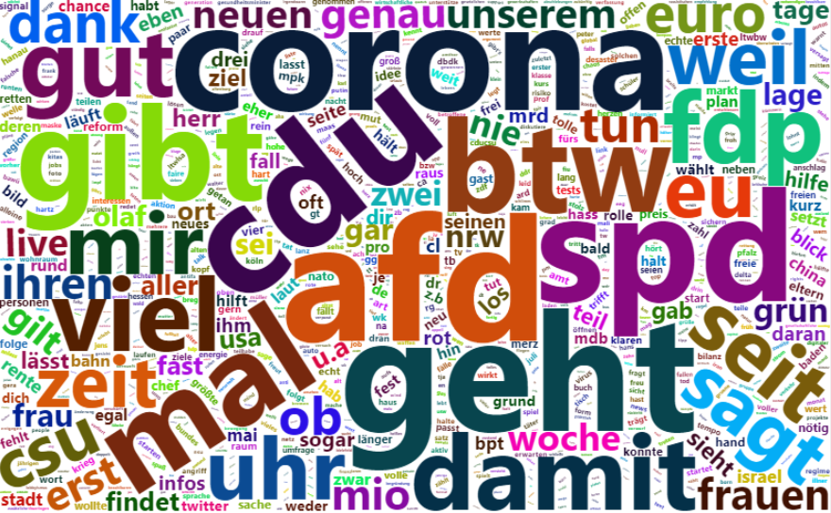

**Political Marketing**

|  |  |
| --- | --- |
| SPD | CDU/CSU |
| Greens | FDP |
| AfD | Left |

**Figures A9-A14 - WordClouds of Hashtags (Political Marketing)**

|  |  |
| --- | --- |
| SPD | CDU/CSU |
| Greens | FDP |
| AfD | Left |

**Table A2 – Summary Statistics for the User-Generated Discussions Data**

**Data Set 2 – User-Generated Discussions: 70 variables x 297775 observations**

|  |  |  |  |  |  |  |
| --- | --- | --- | --- | --- | --- | --- |
| **ID Variables** | **Time Variables** | **Text Variables** | **Location Variables** | **Analysis Variables** | **Dummy Variables** | **Count & Type Variables** |
| query, user_id, reply_to_status_id, reply_to_user_id,  mentions_user_id, retweet_status_id,  retweet_user_id,  retweet_name, mentions_screen_name,  name | created_at, retweet_created_at, account_created_at | text, hashtags, retweet_text description | location, retweet_location | party_id, candidate_id, election_id, campaign_id, U_syuzhet, U_bing, U_afinn, U_nrc, U_Sentiment_Index, anger, anticipation, disgust, fear, joy, sadness, surprise, trust, positive, negative, Polarity_Index, Emotion_Index, Intensity_Index | is_quote, is_retweet, AfD, CDU, FDP, Gruene, Linke, SPD, Weidel, Chrupalla, Laschet, Dobrindt, Lindner, Baerbock, Habeck, Wissler, Bartsch, Scholz | favorite_count, retweet_count, retweet_favorite_count, retweet_retweet_count, retweet_followers_count, retweet_friends_count, urls_url, media_url, media_type, photo, ext_media_url, verified, retweet_verified |
| **No Party** | **SPD** | **CDU/CSU** | **Greens** | **FDP** | **AfD** | **Left** |
| 118438 | 19127 | 67417 | 19509 | 10966 | 54907 | 7411 |
| **Reach & Dissemination (per Account)** | |  |  |  |  |  |
| - Avg. Favorite Count | 2.85 | 2.38 | 2.87 | 3.26 | 2.51 | 2.61 |
| - Avg. Retweet Count | 99.97 | 127.04 | 95.58 | 162.23 | 97.05 | 32.96 |
| - Avg. Text Width | 148.96 | 156.19 | 151.68 | 147.90 | 147.52 | 154.53 |

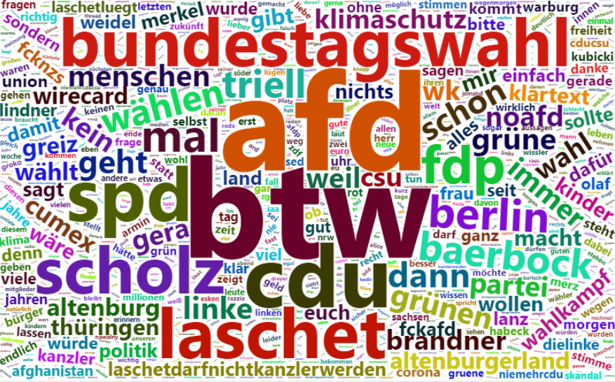

**Figures A15 – WordCloud of Tweet Texts (User-Generated Discussions)**

**User-Generated Discussions – Search Queries (Hashtags)**

The list of search queries continuously increased weekly with the progress of this research and additional conversation topics in the following weeks. Hence, there are multiple iterations of query lists. In the following, the used queries are presented.

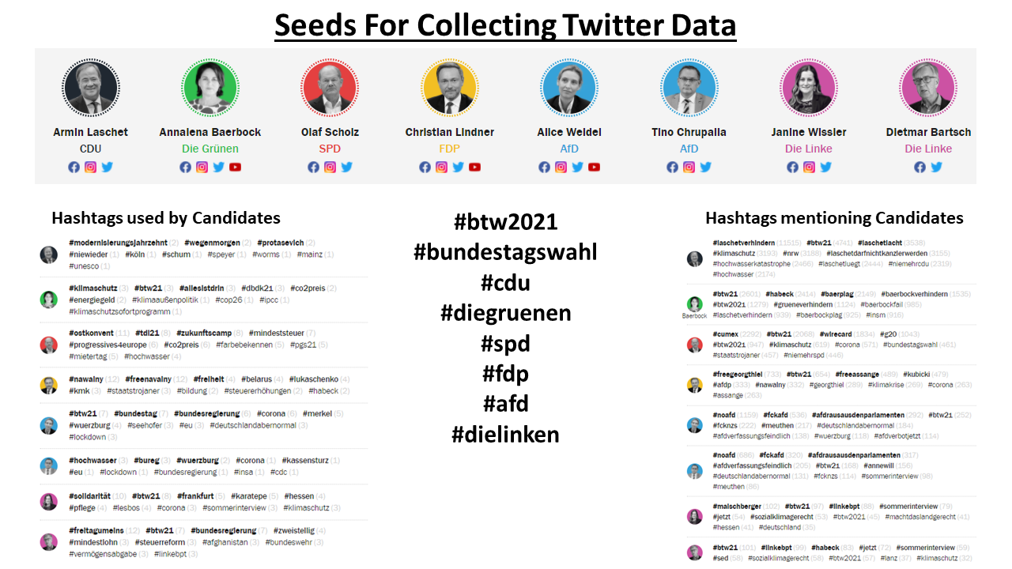

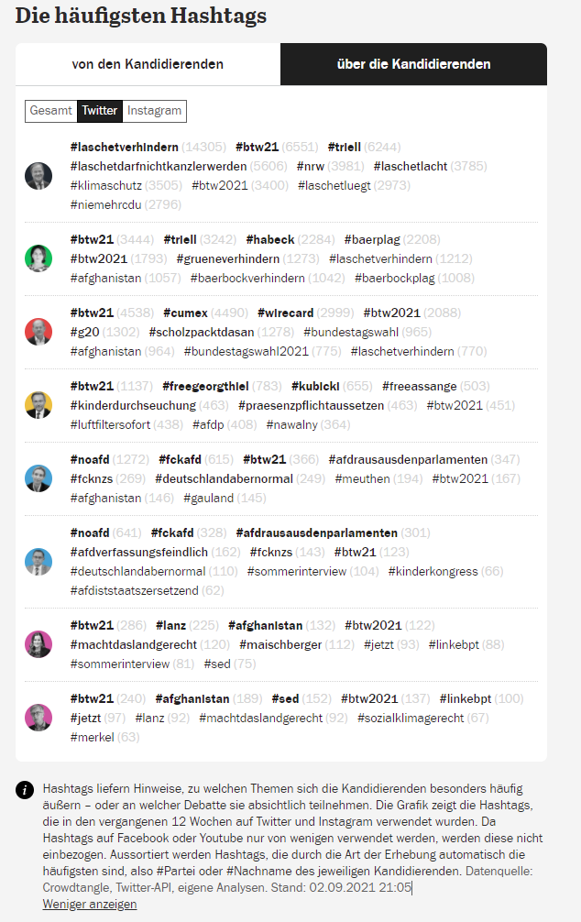

**Seeds – First Iteration (first week of data collection)**

Source: Tagesspiegel 2021

|  |  |
| --- | --- |
|  |  |
|  |  |

**Seeds – Second Iteration (second and third week of data collection)**

Source: Tagesspiegel 2021



**Seeds – Third Iteration (fourth week of data collection)**

Source: Tagesspiegel 2021

The relevant hashtags were drawn from the trending hashtags lists on the real-time social media dashboard specifically created for the 2021 federal election by the Berlin newspaper Tagesspiegel in cooperation with Democracy Reporting International and Stiftung Mercator (Tagesspiegel 2021).

**Appendix B. Results**

**Sentiment & Emotion Analysis**

**Table B1 – Sentiment and Emotions of Parties (Political Marketing)**

|  |  |  |  |  |  |  |
| --- | --- | --- | --- | --- | --- | --- |
|  | **SPD** | **CDU/CSU** | **Greens** | **FDP** | **AfD** | **Left** |
| Sentiment Index | -0.6255 | -0.6307 | 0.6777 | -0.6983 | -0.7348 | -0.8203 |
| Syuzhet | -0.3353 | -0.3302 | -0.3587 | -0.3679 | -0.3953 | 0.4433 |
| Bing | -0.3988 | -0.4076 | -0.4448 | -0.4684 | -0.4910 | -0.5378 |
| Afinn | -1.2823 | -1.3101 | -1.3785 | -1.3994 | -1.4699 | -1.6494 |
| NRC | -0.4856 | -0.4748 | -0.5287 | -0.5575 | -0.5830 | -0.6508 |
| Positive | 0.4491 | 0.4237 | 0.4046 | 0.4134 | 0.3462 | 0.3835 |
| Negative | 0.2636 | 0.2694 | 0.2992 | 0.3128 | 0.3189 | 0.3268 |
| Intensity Index | 0.8718 | 0.8766 | 0.8803 | 0.8609 | 0.8767 | 0.9160 |
| Anger |  |  |  |  |  |  |
| Anticipation |  |  |  |  |  |  |
| Disgust |  |  |  |  |  |  |
| Fear |  |  |  |  |  |  |
| Joy |  |  |  |  |  |  |
| Sadness |  |  |  |  |  |  |
| Surprise |  |  |  |  |  |  |
| Trust |  |  |  |  |  |  |

**Table B2 – Sentiment and Emotions of Parties (User-Generated Discussions)**

|  |  |  |  |  |  |  |
| --- | --- | --- | --- | --- | --- | --- |
|  | **SPD** | **CDU/CSU** | **Greens** | **FDP** | **AfD** | **Left** |
| Sentiment Index |  |  |  |  |  |  |
| Syuzhet |  |  |  |  |  |  |
| Bing |  |  |  |  |  |  |
| Afinn |  |  |  |  |  |  |
| NRC |  |  |  |  |  |  |
| Positive |  |  |  |  |  |  |
| Negative |  |  |  |  |  |  |
| Intensity Index |  |  |  |  |  |  |
| Anger |  |  |  |  |  |  |
| Anticipation |  |  |  |  |  |  |
| Disgust |  |  |  |  |  |  |
| Fear |  |  |  |  |  |  |
| Joy |  |  |  |  |  |  |
| Sadness |  |  |  |  |  |  |
| Surprise |  |  |  |  |  |  |
| Trust |  |  |  |  |  |  |

**Table B3 – Sentiment and Emotions of Candidates (Political Marketing)**

|  |  |  |  |  |  |  |
| --- | --- | --- | --- | --- | --- | --- |
|  | **SPD** | **CDU/CSU** | **Greens** | **FDP** | **AfD** | **Left** |
| Sentiment Index |  |  |  |  |  |  |
| Syuzhet |  |  |  |  |  |  |
| Bing |  |  |  |  |  |  |
| Afinn |  |  |  |  |  |  |
| NRC |  |  |  |  |  |  |
| Positive |  |  |  |  |  |  |
| Negative |  |  |  |  |  |  |
| Intensity Index |  |  |  |  |  |  |
| Anger |  |  |  |  |  |  |
| Anticipation |  |  |  |  |  |  |
| Disgust |  |  |  |  |  |  |
| Fear |  |  |  |  |  |  |
| Joy |  |  |  |  |  |  |
| Sadness |  |  |  |  |  |  |
| Surprise |  |  |  |  |  |  |
| Trust |  |  |  |  |  |  |

**Table B4 – Sentiment and Emotions of Candidates (User-Generated Discussions)**

|  |  |  |  |  |  |  |
| --- | --- | --- | --- | --- | --- | --- |
|  | **SPD** | **CDU/CSU** | **Greens** | **FDP** | **AfD** | **Left** |
| Sentiment Index |  |  |  |  |  |  |
| Syuzhet |  |  |  |  |  |  |
| Bing |  |  |  |  |  |  |
| Afinn |  |  |  |  |  |  |
| NRC |  |  |  |  |  |  |
| Positive |  |  |  |  |  |  |
| Negative |  |  |  |  |  |  |
| Intensity Index |  |  |  |  |  |  |
| Anger |  |  |  |  |  |  |
| Anticipation |  |  |  |  |  |  |
| Disgust |  |  |  |  |  |  |
| Fear |  |  |  |  |  |  |
| Joy |  |  |  |  |  |  |
| Sadness |  |  |  |  |  |  |
| Surprise |  |  |  |  |  |  |
| Trust |  |  |  |  |  |  |

**General Stance Analysis**

**Table B5 – RILE Indices**

|  |  |  |  |  |  |  |
| --- | --- | --- | --- | --- | --- | --- |
|  | **SPD** | **CDU/CSU** | **Greens** | **FDP** | **AfD** | **Left** |
| **RILE Index Program**  **Election I** | -21.453 | 2.758 | -21.057 | 0.576 | 17.429 | -41.912 |
| **RILE Index Program**  **Election II** | -24.673 | 3.495 | -21.037 | 0.265 | 26.050 | -36.168 |
| **RILE Difference Between Programs** | -3.22 | +0.737 | -0.020 | -0.311 | +8.621 | +5.744 |



**Figure B1 – RILE Index (1990-2021)**

**Table B6 – Reference Scores (2019 Chapel Hill Expert Survey)**

|  |  |  |  |  |  |  |
| --- | --- | --- | --- | --- | --- | --- |
|  | **SPD** | **CDU/CSU** | **Greens** | **FDP** | **AfD** | **Left** |
| **Overall Ideological Score**  left vs. right | 3.619 | 6.524 | 3.238 | 6.429 | 9.238 | 1.429 |
| Economic Issues Score  left vs. right | 3.714 | 6.143 | 3.810 | 7.905 | 7.000 | 1.286 |
| Social & Cultural Values Score  libertarian vs. traditional | 3.381 | 6.571 | 1.095 | 3.429 | 9.524 | 2.810 |
| Immigration Policy Score  liberal vs. restrictive | 4.150 | 6.850 | 1.700 | 5.950 | 9.900 | 2.700 |
| Environmental Score  sustainability vs. econ. growth | 4.700 | 6.125 | 1.550 | 7.526 | 8.450 | 4.250 |
| State Spendings Score  public services vs. tax reduction | 3.053 | 6.395 | 3.158 | 8.895 | 7.286 | 1.000 |
| Identity Score  cosmopolitanism vs. nationalism | 3.421 | 6.211 | 1.105 | 3.895 | 9.684 | 2.895 |
| Trade Orientation Score  liberalization vs. protectionism | 4.222 | 3.778 | 3.882 | 1.611 | 6.688 | 6.222 |
| Civil Score  civil liberties vs. law & order | 4.050 | 7.150 | 1.850 | 3.450 | 9.500 | 2.421 |

*Reference scores for the Quanteda WordScore algorithm. The values for each party were taken from the Chapel Hill Expert Survey 2019 (n:21), an expert evaluation of stances based on party programs in 2019, used as reference scores for the 2017 party programs in the prediction of wordscores (left to right; scale 0-10).*

**Table B7 – General Stance Analysis**

|  |  |  |  |  |  |  |
| --- | --- | --- | --- | --- | --- | --- |
| **Party** | **SPD** | **CDU/CSU** | **Greens** | **FDP** | **AfD** | **Left** |
| **Reference Score**  **CH Overall** Ideo. Score | **3.619** | **6.524** | **3.238** | **6.429** | **9.238** | **1.429** |
| Party Program (2017)  Quanteda score | 4.560 | 4.828 | 4.474 | 4.950 | 5.368 | 4.292 |
| PP 2017 SE | 0.0040 | 0.0062 | 0.0031 | 0.0046 | 0.0094 | 0.0038 |
| Party Program (2021)  Quanteda score | 4.605 | 4.715 | 4.650 | 4.885 | 5.015 | 4.556 |
| PP 2021 SE | 0.0056 | 0.0038 | 0.0033 | 0.0047 | 0.0068 | 0.0040 |
| Tweets (2021)  Quanteda score | 4.777 | 4.818 | 4.753 | 4.817 | 4.854 | 4.739 |
| T 2021 SE | 0.0010 | 0.0009 | 0.0009 | 0.0009 | 0.0014 | 0.0011 |
| Difference Program-Program (2017-2021) | +0.045 | +0.113 | +0.176 | -0.065 | -0.353 | +0.264 |
| Difference Tweets-Program (2021) | +0.172 | +0.103 | +0.103 | -0.068 | -0.161 | +0.183 |

*Relative Left-Right WordScore positions of party programs and tweets for each of the major political parties (2017+2021). Based on the assignment of the Chapel Hill Expert Survey (2019) scores as reference values for the 2017 federal election party programs, the relative position of the party programs and tweets in 2021 was predicted by the Quanteda WordScore algorithm.*



**Figure B2 – General Stance Analysis**

**Table B8 – Lexical Diversity**

|  |  |  |  |  |  |  |
| --- | --- | --- | --- | --- | --- | --- |
| **Party** | **SPD** | **CDU** | **Greens** | **FDP** | **AfD** | **Left** |
| **PP 2017** | 0.4622 | 0.4392 | 0.3959 * | 0.4728 | 0.6152 ** | 0.5036 |
| **PP 2021** | 0.4905 | 0.3969 * | 0.4087 | 0.4960 | 0.6035 ** | 0.4686 |
| **T 2021** | 0.1279 | 0.1200 | 0.1047 * | 0.1181 | 0.1619 ** | 0.1222 |

*Lexical Diversity of the party programs in 2017 and 2021, as well as the tweets in the Political Marketing data. Grouped by party. Maximum (**) and minimum (*) values.*

**Table B9 – Similarity Between Authors (SBA)**

|  |  |  |  |  |  |  |
| --- | --- | --- | --- | --- | --- | --- |
| **Party** | **SPD** | **CDU** | **Greens** | **FDP** | **AfD** | **Left** |
| **Median Distance** | 196.60 | 202.20 | 233.52 | 222.94 | 145.30 * | 257.82 ** |
| **Mean Distance** | 219.40 | 209.23 | 270.75 | 242.75 | 176.66 * | 281.75 ** |
| **IQR Distance** | 137.10 | 166.89 | 137.10 | 124.05 * | 167.02 | 180.06 ** |

*Similarity Between Authors (SBA) in the Political Marketing data. Grouped by party. Maximum (**) and minimum (*) values.*

Clustering is an adequate visualization of Similarity Between Authors (SBA). The clustering algorithm *ward.D2* utilizes the Ward’s minimum variance method by squaring the dissimilarities before clustering (UA Alberta 2021). This method was chosen because of two reasons. Firstly, because it allows us to identify latent groups within each party that are dissimilar to each other measured in SBA. Secondly, because by squaring the dissimilarities before clustering, this method makes small dissimilarities proportionally easier to identify – an issue that is likely to arise with large sample sizes for clustering like the number of candidates for each party in this research.

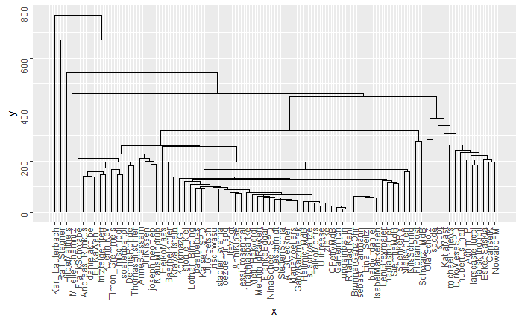

**Figure B3 – SPD Dendrogram I (Similarity Between Authors Clustering)**

*Complete Linkage Method.*

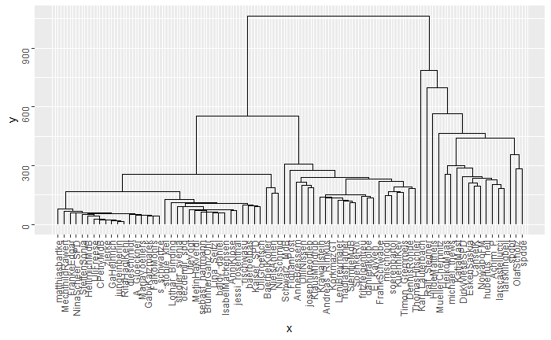

**Figure B4 – SPD Dendrogram II (Similarity Between Authors Clustering)**

*Ward.D2 Method.*

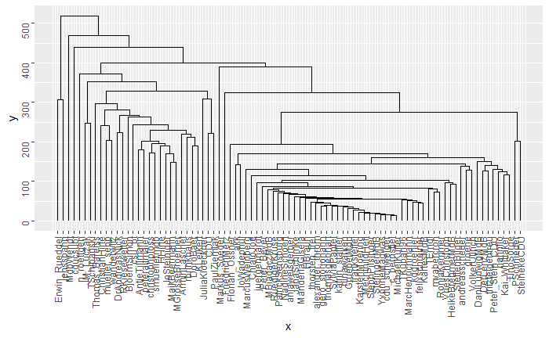

**Figure B5 – CDU/CSU Dendrogram I (Similarity Between Authors Clustering)**

*Complete Linkage Method.*

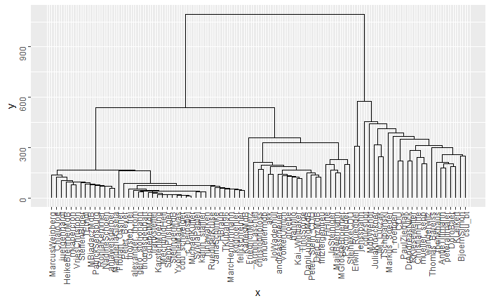

**Figure B6 – CDU/CSU Dendrogram II (Similarity Between Authors Clustering)**

*Ward.D2 Method.*

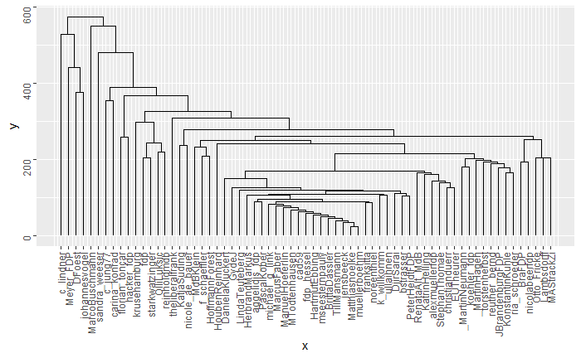

**Figure B7 – FDP Dendrogram I (Similarity Between Authors Clustering)**

*Complete Linkage Method.*

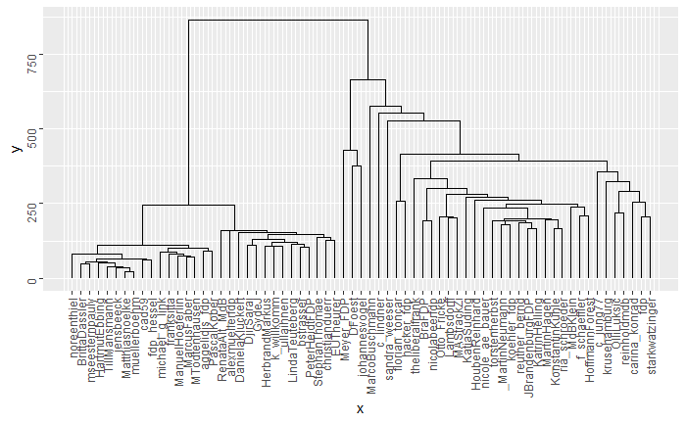

**Figure B8 – FDP Dendrogram II (Similarity Between Authors Clustering)**

*Ward.D2 Method.*

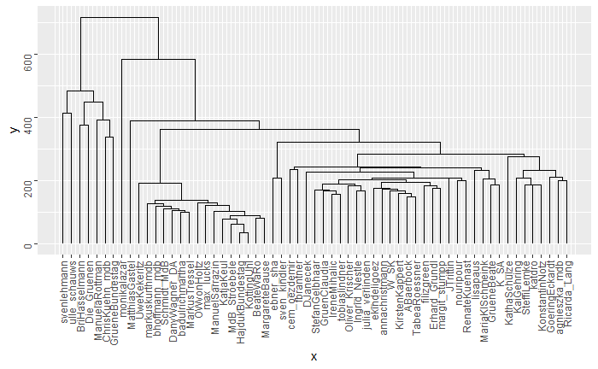

**Figure B9 – The Greens Dendrogram I (Similarity Between Authors Clustering)**

*Complete Linkage Method.*

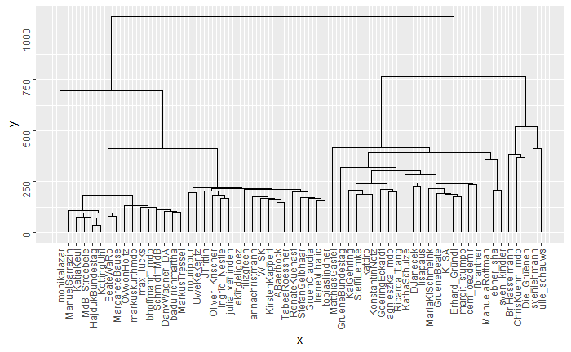

**Figure B10 – The Greens Dendrogram II (Similarity Between Authors Clustering)**

*Ward.D2 Method.*

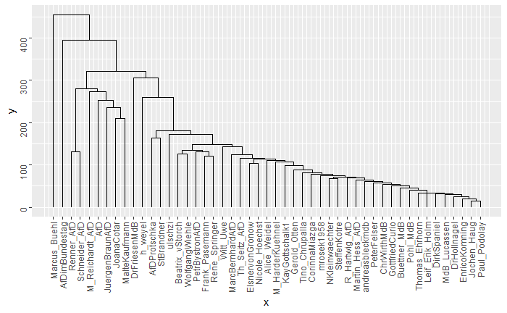

**Figure B11 – AfD Dendrogram I (Similarity Between Authors Clustering)**

*Complete Linkage Method.*

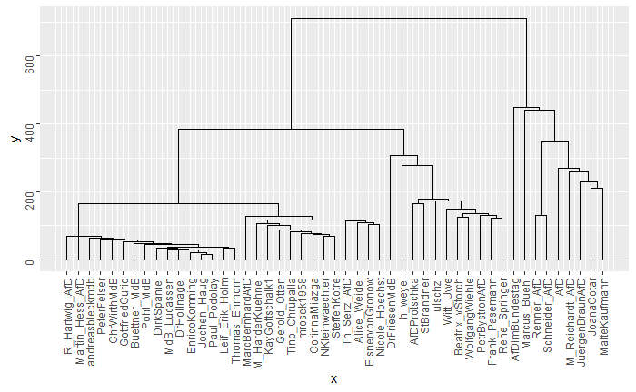

**Figure B12 – AfD Dendrogram II (Similarity Between Authors Clustering)**

*Ward.D2 Method.*

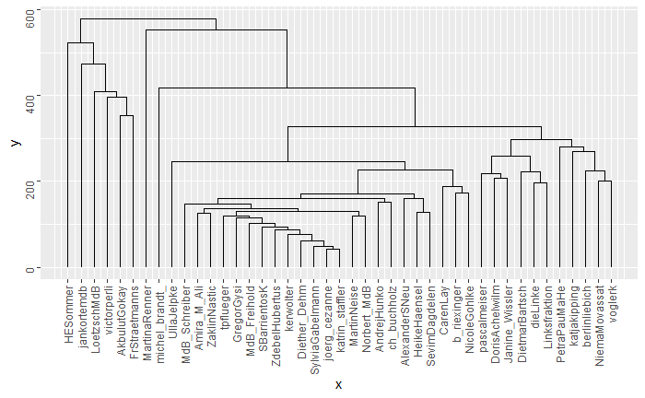

**Figure B13 – The Left Dendrogram I (Similarity Between Authors Clustering)**

*Complete Linkage Method.*

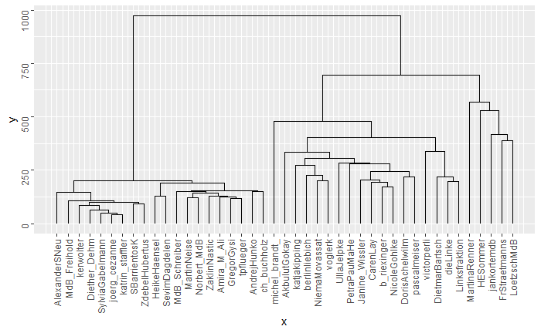

**Figure B14 – The Left Dendrogram II (Similarity Between Authors Clustering)**

*Ward.D2 Method.*

**Topic-Specific Stance Analysis**

**Table B10-B12 – Topic-Specific Stances**

|  |  |  |  |  |  |  |
| --- | --- | --- | --- | --- | --- | --- |
| **Party** | **SPD** | **CDU/CSU** | **Greens** | **FDP** | **AfD** | **Left** |
| Tweets (2021)  Quanteda score | 4.7663 | 4.7648 | 4.7590 | 4.7753 | 4.7778 | 4.7648 |
| Corona Tweets (2021)  Quanteda score | 4.7686 | 4.7662 | 4.7607 | 4.7770 | 4.7787 | 4.7662 |
| Difference Tweets-Corona-Tweets (2021) | +0.0023 | +0.0014 | +0.0017 | +0.0017 | +0.0009 | +0.0012 |
| SE Tweets | 2.5377e-05 | 2.4547e-05 | 2.7749e-05 | 3.4189e-05 | 4.6831e-05 | 2.6589e-05 |
| SE Cor. Tweets | 7.3095e-05 | 6.3244e-05 | 1.0885e-04 | 8.5752e-05 | 1.1300e-04 | 8.0612e-05 |

|  |  |  |  |  |  |  |
| --- | --- | --- | --- | --- | --- | --- |
| **Party** | **SPD** | **CDU/CSU** | **Greens** | **FDP** | **AfD** | **Left** |
| Tweets (2021)  Quanteda score | 4.7663 | 4.7648 | 4.7590 | 4.7753 | 4.7778 | 4.7648 |
| Environment Tweets (2021)  Quanteda score | 4.7617 | 4.7622 | 4.7542 | 4.7738 | 4.7737 | 4.7617 |
| Difference Tweets- Env. -Tweets (2021) | -0.0046 | -0.0026 | -0.0048 | -0.0015 | -0.0041 | -0.0031 |
| SE Tweets | 2.5378e-05 | 2.4548e-05 | 2.7750e-05 | 3.4187e-05 | 4.6833e-05 | 2.6590e-05 |
| SE Env. Tweets | 1.3489e-04 | 1.2767e-04 | 8.6502e-05 | 1.9730e-04 | 3.2660e-04 | 1.7234e-04 |
| **Party** | **SPD** | **CDU/CSU** | **Greens** | **FDP** | **AfD** | **Left** |
| Tweets (2021)  Quanteda score | 4.7663 | 4.7648 | 4.7590 | 4.7753 | 4.7778 | 4.7648 |
| Digitization Tweets (2021)  Quanteda score | 4.7656 | 4.7645 | 4.7607 | 4.7756 | 4.7764 | 4.7654 |
| Difference Tweets- Dig.-Tweets (2021) | -0.0007 | -0.0003 | +0.0017 | +0.0003 | -0.0014 | -0.0006 |
| SE Tweets | 2.5378e-05 | 2.4549e-05 | 2.7750e-05 | 3.4186e-05 | 4.6833e-05 | 2.6590e-05 |
| SE Dig. Tweets | 1.5616e-04 | 1.1466e-04 | 1.4796e-04 | 1.6474e-04 | 5.5794e-04 | 2.6575e-04 |



**Figure B15 – Topic-Specific Stances**

**Note:** Due to some very similar positionings, some demarcations for parties overlap each other (e.g., CDU/CSU and Left in overall tweet stances).

**Topic 1 - Corona / Covid-19 Pandemic**



**Figure B16 – Corona-specific tweets (entire campaign term)**

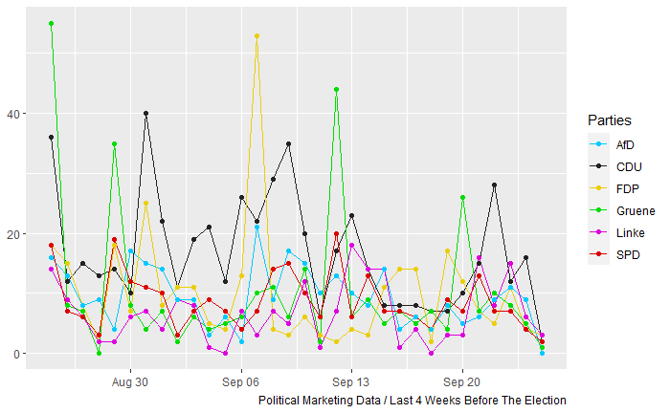

**Figure B17 – Corona-specific tweets (last four weeks)**

**Topic 2 - Environment / Climate Change**

**

**Figure B18 – Environment-specific tweets (entire campaign term)**

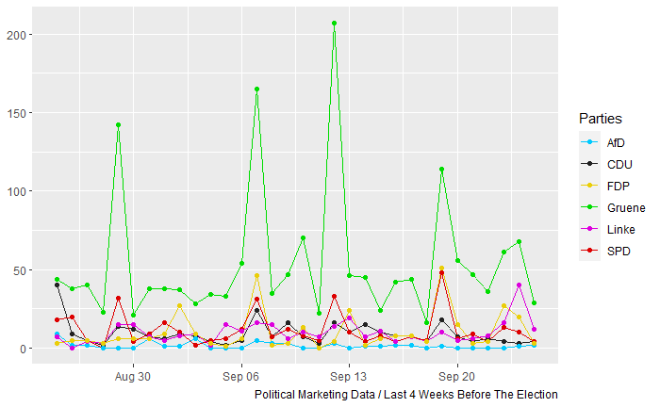

**Figure B19 – Environment -specific tweets (last four weeks)**

**Topic 3 - Digitization**

**

**Figure B20 – Digitization-specific tweets (entire campaign term)**

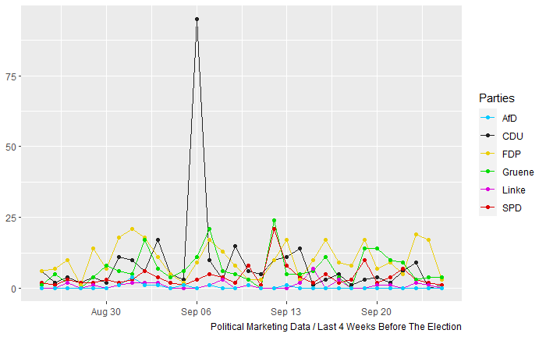

**Figure B21 – Digitization-specific tweets (last four weeks)**

**Appendix D. Model-Free Analysis**

|  |  |
| --- | --- |
| **First Votes (2017)**    *Source: Wikimedia (2017)* | **First Votes (2021)**    *Source: Wikimedia (2021a)* |
| **Changes in First Votes from 2017 to 2021**    *Source: Wikimedia (2021b)*  **CDU FDP**  **SPD AfD**  **GRUENE LINKE** | |

**Figure C1 – Electoral Constituencies (2017 & 2021)**

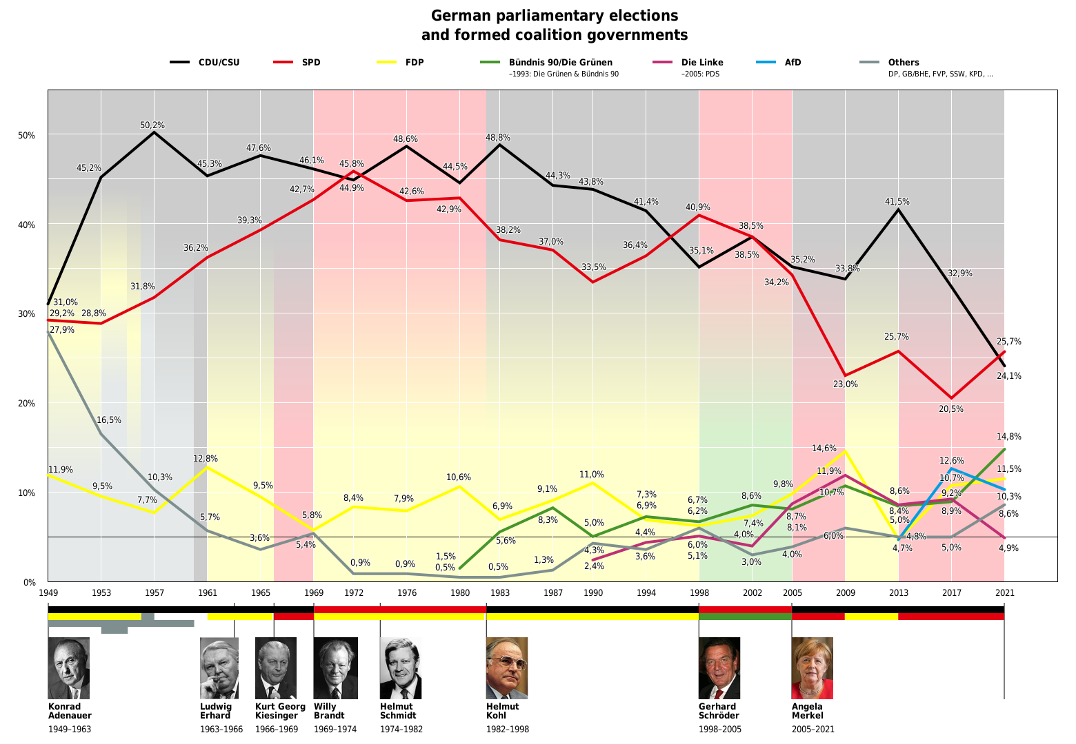

**Figure C2 – Second Votes (1949-2021): History of federal election results in percent of second votes, formed coalitions and chancellors in Germany (Source: Wikimedia 2021c)**

|  |
| --- |
|  |

**Figure C3: Regression of Poll Data for the Major Political Parties in the last legislature period (2017-2021). Key events during this time period are marked (Sources: Politico 2021, Bundeswahlleiter 2021f, Eckstein et. al. 2021, Wahlrecht 2021, Wiwo 2021a, Wiwo 2021b, bpb 2021c)**

**Appendix D. German Political System**

**Electoral System**

The Bundestag is the parliament and subsequently primary legislative body of the Federal Republic of Germany. Its members are regularly elected every four years by the German people as their representatives through general elections. The primary duties of the Bundestag are to elect the head of government, discuss and pass laws, control the government's ongoing work, and articulate current political problems as the forum of the nation. Members of the same party within the parliament are organized in factions, which usually act unanimously in parliament votes once they conclude a consensus agreement in their internal discussions (bpb 2021b). The German federal elections are organized with proportional representation voting. Each eligible voter has two votes. With the first vote, the voter determines which candidate is supposed to directly represent the electoral constituency in which he or she is registered. The candidate with the highest number of votes wins the direct mandate. With the second vote, the voter determines which party is supposed to represent him or her in the parliament. The second vote results are operationalized with hierarchical candidate lists made by each party, respectively. If a party receives 30% of the second votes in the federal elections, this party earns 30% of the seats in the parliament for the upcoming legislative period. Subsequently, the first 30% of the party’s candidate list are elected to be part of the parliament. Hence, the second vote is usually regarded as the more impactful vote (lpb 2021).

There are a couple of noteworthy peculiarities in the electoral system of Germany. Firstly, if a party wins more direct mandates with the first votes than they technically earned seats with the second votes, the winning direct candidates are still allowed to be members of the new parliament (Überhangmandate). In this event, these mandates are balanced with additional mandates to the other parties according to the proportions of the second vote results (Ausgleichsmandate). This way, the additional mandates restore the second votes' actual proportions while also accounting for the first vote results. Secondly, a party only receives seats in the parliaments if at least one of two conditions is satisfied. They either need to account for at least five percent of the second votes (Sperrklausel) or win at least three direct mandates (Grundmandatsklausel) (Bundeswahlleiter 2021b; lpb 2021).

**Social Democrats (SPD)**

Founded in 1863 as the Sozialdemokratische Partei Deutschlands, the Social Democrats (SPD) embody the oldest German party. Giving up its adherence to Marxism with the Godesberg Program in 1959, the SPD began to open up as a party of the people in the late 1950s, becoming the typical representation of its traditional clientele of industrial workers, as well as a large proportion of middle-class voters. Its program can be characterized by the values of freedom, justice, and solidarity (Decker 2021d, Krell & Woyke 2015).

From 1966 to 1982, the Social Democrats were a governing party for 16 years, initially as a minor partner of the CDU/CSU and from 1969 under Chancellors Willy Brandt and Helmut Schmidt in a coalition with the FDP. Programmatically, it set priorities in economic policies (Keynesianism), as well as in the normalization of relations between West Germany and Eastern Europe, in particular East Germany (*Ostpolitik*) (Decker 2020d). The beginning of the conservative Merkel era in 2005 also marked the beginning of a downward spiral for the Social Democrats, gaining the party’s worst election results in its history twice in three consecutive elections from 2009 to 2017 (Decker 2020d, Lynen von Berg 2019, Walter 2018). Even before the Godesberg program from 1959, the Social Democrats had never been a pure class party. On the one hand, the working class in the Catholic part of the population remained inaccessible to them for a long time.

On the other hand, the SPD began to open up to the rapidly growing white-collar professions as early as the Weimar Republic, in whose group it soon did better than among the workers (Lösche & Walter 1992). Since the 1990s, the focal points in the occupational structure of the Social Democrats electorate have been fading away. While the SPD consistently achieved absolute majorities among unionized workers from 1994 to 2008, it fell back to 34 percent in this group in 2009. Among the unemployed, too, its share of 19 percent was now well below its overall result. In absolute terms, the SPD lost around ten million voters in 2009 compared with 1998: just under a quarter of them (2.4 million) stayed away from the polls, while more than a fifth (2.1 million) defected to the Left Party (Decker 2020d, Spier & von Alemann 2013).

**Christian Democrats (CDU/CSU)**

Founded in 1945 as the *Christlich Demokratische Union Deutschlands*, the Christian Democrats (CDU/CSU) represent a conservatively oriented rallying party of the Christian-bourgeois camp in Germany. Typically associated with anti-socialist orientation, its program is characterized by conservative, liberal and Christian-social positions, the modernization of which repeatedly touches on core elements of the party's identity. As the only major twin party in Germany, the union is constituted by technically two different parties, as the CDU acts as its representative in 15 of 16 German states, while the CSU only exists in Bavaria instead of the CDU (Decker 2021c, Bösch 2018, Zolleis & Schmid 2013, Bösch 2002).

Chancellor Konrad Adenauer's leadership of the Federal Republic in the West and the economic miracle guaranteed the CDU stable voter majorities until the mid-1960s (Bösch 2001). The loss of government power in 1969 initiated the transformation into a modern program and membership party, predominantly driven by Helmut Kohl, who led it back to the government in 1982 (Kleinmann 1993). The significant achievements of 16 years Kohl administrations are the restoration of German unity and the introduction of the euro. After losing the majority in 1998, the CDU quickly recovered under Angela Merkel. The party thus laid the foundation for regaining the chancellorship in 2005, which it defended in the three subsequent federal elections as the strongest force in the party system (Decker 2021b & Brechenmacher 2020).

Following Merkel's announcement of her intention to step down from the positions of chancellor and chairwoman, the CDU found itself in a leadership crisis (Decker 2021c, Decker 2020a, Bösch 2018, Zolleis & Schmid 2013). Like other parties, the CDU is suffering from a thinning of its natural core clientele: its popularity among senior citizens has been declining since the 1990s, and the group of church-affiliated voters traditionally inclined toward it hardly carries any weight among the population anymore. The CDU/CSU receives relatively equal support from the various social and occupational groups, underscoring its character as a people's party. The CDU receives above-average support from farmers, the self-employed, pensioners, civil servants, and below-average support from white-collar and blue-collar workers (Decker 2021c, Bösch 2018, Zolleis & Schmid 2013).

**The Greens**

Founded in 1993 as Bündnis 90 / Die Grünen, when the western Greens merged with the eastern Bündnis 90, the Greens were the most successful newly founded party in the history of the Federal Republic until the emergence of the AfD. They were founded in protest against environmental destruction, the use of nuclear energy and nuclear armament. Since the 1980s, they have established themselves permanently as the fourth force in the party system alongside the CDU/CSU, SPD, and FDP (Decker 2020c, Probst 2015, Probst 2013, Anan 2013).

In the 1980s, the development of the new party was accompanied by fierce struggles over direction. The conservative-bourgeois representatives who had been part of its founding spectrum turned their backs on the Greens as early as the beginning of the 1980s. The subsequent disputes centered on the question of possible government participation, which was sought in principle by the moderate left-wing ("realos") and just as resolutely rejected by the radical left-wing ("fundis") (Anan 2013, Klein & Falter 2003, Kleinert 1992). At the state level, the Greens formed the first red-green coalition in Hessen in 1985, which became the model for numerous other government participations and their seven-year term in government (1998 to 2005) at the federal level. From 2008, they began to open up to coalitions with the Conservatives, thereby assuming a hinge function in the formation of governments. While the Greens were still in sixth place in the 2017 federal election, since the end of 2018, they have succeeded in outstripping all opposition parties and the SPD as the second-strongest force to date in nationwide polls (Decker 2020c).

A programmatic challenge for the party is the changed composition of its electorate. On the one hand, voters who voted for the Greens thirty years ago and have remained loyal to them ever since are now in predominantly privileged circumstances so that they could be put off by overly left-wing positions on social and economic policy. On the other hand, the Greens continue to achieve above-average results among young voters. They traditionally enjoy strong support among women (Decker 2020c, Probst 2013, Switek 2012).

**Liberal Democrats (FDP)**

Founded in 1948 as the Freie Demokratische Partei, the Liberal Democrats (FDP) were the only small party formed at the beginning of the Federal Republic to permanently secure its parliamentary existence along with the big parties of CDU/CSU and SPD. The Liberal Democrats have been occupying a pivotal role in forming coalitions, as they have been the favorite minority partner in coalitions by both CDU/CSU and SPD. With its liberal economic positions and restrictive stance on refugee and European policy, it has an above-average reach among higher-income voters (Decker 2021a, Treibel 2018, Walter 2010).

Despite the deep crisis into which the party plunged after its record results in 2009, its failure to clear the five-percent hurdle in the 2013 federal election came unexpectedly. After the setback, it managed an impressive resurgence under the young chairman Christian Lindner. In 2017, it returned to the Bundestag more than doubling its result from 2013 but now refused to participate in the government again, terminating talks with Conservatives and Greens to form a new government (Decker 2021a, Treibel 2018 & Niedermayer 2015). The election results of the Liberal Democrats are subject to strong fluctuations, especially at the municipal and state level. Because the party has only a small core voter potential, its support depends primarily on situational factors such as its economic competence or need as a coalition partner. Higher-income voters with higher formal educational qualifications support the FDP more than average. Men and younger age groups are also disproportionately represented in its electorate (Decker 2021a, Treibel 2018, Freckmann 2018 & Walter 2010).

**Alternative for Germany (AfD)**

Founded in 2013 as Alternative für Deutschland in response to measures to combat the European currency crisis, the Alternative has most notably fought for restrictive immigration policy, a conservative social policy, and an anti-establishment orientation. Now typically identified as a right-wing populist party, the Alternative has been successful in all elections since 2014. The Alternative became the first right-wing party in post-war Germany to earn representatives in each of the 16 state parliaments and the Bundestag (Decker 2020b, Lewandowsky 2018, Decker 2016).

With former CDU members Bernd Lucke and Alexander Gauland as driving forces behind the founding process, the party developed a moderate ideological profile that combined liberal positions with conservative positions and mainly focused on the euro issue. After the party had narrowly failed to clear the five-percent hurdle in the 2013 federal election, the young party entered a divisive split. The predominant conservative camp led by Lucke lost his support within the party in favor of the more right-wing oriented camp led by Frauke Petry, eventually being replaced by her as party chairman in 2015 (Bebnowski 2015, Häusler & Roeser 2015). Following a considerable shift to the right, the party was able to gain considerable voter support. The European migrant crisis beginning in 2015 was a significant factor in this, bringing it record results in the state elections of 2016. In the 2017 federal election, it almost tripled the number of its voters compared to 2013. It entered the Bundestag with a double-digit result as the third-strongest force (Decker 2020b, Lewandowsky 2018).

The Alternative has been in crisis since 2018: the further strengthening of the far-right forces around Höcke and Andreas Kalbitz, and the classification of parts of the party as "secured far-right" published by the Office for the Protection of the Constitution (Verfassungsschutz) in March 2020 is evidence for this, including dropping poll numbers since the beginning of the pandemic. These events have increased the likelihood of a renewed split in the AfD (Ruhose 2020). The Alternative has twice as much voter potential in the eastern states as in the west. Almost two-thirds of AfD voters are male, with the middle age groups dominating. No clear pattern can be discerned among the occupational groups. However, the Alternative seems to be particularly successful among voters at risk of falling from the social ladder (Decker 2020b, Hambauer & Mays 2018, Niedermayer & Hofrichter 2016).

**The Left**

Founded in 2007 as *Die Linke*, the Left Party assembles the remnants of the East German Socialist Union Party (*SED*), previously organized in its immediate successor organizations Party of Democratic Socialism (*PDS*) and later also the Labor and Social Justice Party (*WASG*) since the German reunification in 1990. It thus has its roots both in the pro-labor-union environment and the protest against the social policies of the 2000s (Decker 2021b, Neu 2018, Pfahl-Traughber 2013).

After the German reunification, the eastern PDS continued as a quasi-communist party in East Germany and assumed the role of a system-oppositional, capitalism-critical alternative to the existing parties at the federal level (Holzhauser 2019, Decker 2013). After many labor union and SPD members in the states of the West Germany decided to found the party "Labor & Social Justice - The Electoral Alternative" (original: WASG) in 2005 in protest against the policies of the Red-Green government, the PDS used the opportunity to expand into the west and form an all-German Left Party in 2007 (Decker 2021b, Vollmer 2013). The merger was largely driven by former SPD chairman Oskar Lafontaine, who took over the party's leadership together with Lothar Bisky. Under his direction, the Left succeeded in increasing its share of the vote in the west to 8.3 percent in the 2009 federal election and entering several West German state parliaments (Decker 2021b, Pfahl-Traughber 2013).

The disputes over the content of the party's policies are sparked by the question of the extent to which capitalism as a "system" must and can be overcome, by its attitude toward the SED past, and by the party's peace policy positions, which clash with the Federal Republic's foreign and European policy commitments. Correspondingly, relations with Russia also remain a notorious point of contention. Since the mid-2010s, the balance of power in the party has shifted in favor of the West German state associations. While the party is growing in membership and voters there, it is suffering in eastern Germany from its increasing organizational weakness and new competition from the AfD (Decker 2021b, Neu 2018, Niedermayer 2006, Zettl 2004).